*STELLAsTONE*

DOCUMENTS DE MAQUETTE DU LOGICIEL

2022-2023

Table des matières

1 Introduction 4

1.1 Object du document 4

1.2 RéférencE 5

1.2.1 Interface authentification 5

1.2.2 Interface Paramètres 5

1.2.3 Interface Profil 5

1.2.4 Interface Entreprise 5

1.2.5 Interface Réseau spatial 6

1.2.6 Interface Accueil 6

1.2.7 Interface Carte du monde 6

1.2.8 Interface de Voyage 7

1.2.9 Interface de Construction de la fusée 7

1.2.9.1 Interface Mode réaliste 7

1.2.9.2 Interface Mode aventure 8

2 authentification 9

3 accueil 14

4 Profil 24

5 Entreprise 35

6 Reseau spatial 44

7 carte du monde 50

8 Construction de la fusée 54

9 Réalisation de la mission 66

# Introduction

## Object du document

## RéférencE

### Interface authentification

**Image de fond :** <https://www.figma.com/file/ccBWvkQhOMMVcPfAhAjxod/Space-Web-UI-Kit-(Community)?node-id=6%3A7&t=Aot6bQPdOppBX3HU-0>

### Interface Paramètres

**Cosmonaute :** <https://www.figma.com/file/ccBWvkQhOMMVcPfAhAjxod/Space-Web-UI-Kit-(Community)?node-id=6%3A7&t=Aot6bQPdOppBX3HU-0>

**Avatar Utilisateur :** <https://www.pngwing.com/en/free-png-koljx>

### Interface Profil

**Image de Mars :** <https://www.republicworld.com/technology-news/science/mars-atmosphere-details-about-mars-climate-weather-and-more.html>

**Avatar Astronaute :** <https://www.vectorstock.com/royalty-free-vector/astronaut-head-mascot-logo-vector-28892531>

### Interface Entreprise

**Logo Entreprise :** <https://www.shutterstock.com/image-vector/new-world-order-emblem-allseeing-260nw-631301069.jpg>

**Logo SpaceX :** <https://studentwork.prattsi.org/infovis/visualization/https-timeline-knightlab-com-preview-embed/>

### Interface Réseau spatial

**Image galaxie :** <https://www.pinterest.es/pin/647040671439161576/?amp_client_id=CLIENT_ID%28_%29&mweb_unauth_id=&simplified=true>

### Interface Accueil

**Fusée 3D :** <https://sketchfab.com/3d-models/space-shuttle-3d94c44b36564ffcaea1d02dff6a4c74>

**Carte du monde :** <https://favpng.com/png_view/blue-dream-world-map-world-map-illustration-png/8Dppag0L>

### Interface Carte du monde

**Image de fond :**

<https://www.figma.com/file/XqS5IOpo5oPO1MNxCFSGYk/World-map-with-country-names-%2B-flags-(Community)?t=u9DDNlQZOYZcYI7f-6>

### Interface de Voyage

**Image de fond Embarquement :** <https://www.scientificamerican.com/article/spacexs-crew-dragon-signals-sea-change-in-u-s-spaceflight/>

**Image de fond Mise à feu :** <https://interestingengineering.com/culture/european-space-agency-is-aiming-for-its-own-low-cost-reusable-rocket>

**Image de fond Détachement :** <https://fineartamerica.com/featured/1-ares-v-nasa.html>

**Image de fond Injection sur orbite :** <https://spacenews.com/predasar-may-launch-48-satellites-with-spacex-exec-says/>

**Image de fond Vue Extérieure :** https://mobile.twitter.com/OneSpace01/status/1147062764659081217?cxt=HHwWgoCo6bngl-sfAAAA

**Image de fond Vue intérieure :** <https://www.discovermagazine.com/technology/high-precision-star-maps-boost-interstellar-navigation-system>

**Image de fond Découverte planète :** <https://www.imeche.org/news/news-article/feature-the-future-of-nuclear-propulsion>

**Image Vénus 1 :** <https://www.newscientist.com/article/2293335-venuss-surface-may-have-never-been-cool-enough-for-oceans-or-life/>

**Image Vénus 2 :** <https://www.deccanchronicle.com/science/science/200516/mars-earth-sun-will-line-up-perfectly-in-sky-on-sunday.html>

### Interface de Construction de la fusée

#### Interface Mode réaliste

**Image de fond :** <https://www.artstation.com/artwork/WmzeGD>

**Moteur Merlin :** <https://wevolver-project-images.s3.us-west-1.amazonaws.com/0.1x7ucqxtixe3.png>

#### Interface Mode aventure

**Image de fond :** <https://www.cgtrader.com/3d-models/exterior/industrial-exterior/hangar-79a6a206-93e8-4486-aa4f-01cbc9183569>

**Moteur Merlin :** <https://hotcore.info/act/kareff-110791.html>

# authentification

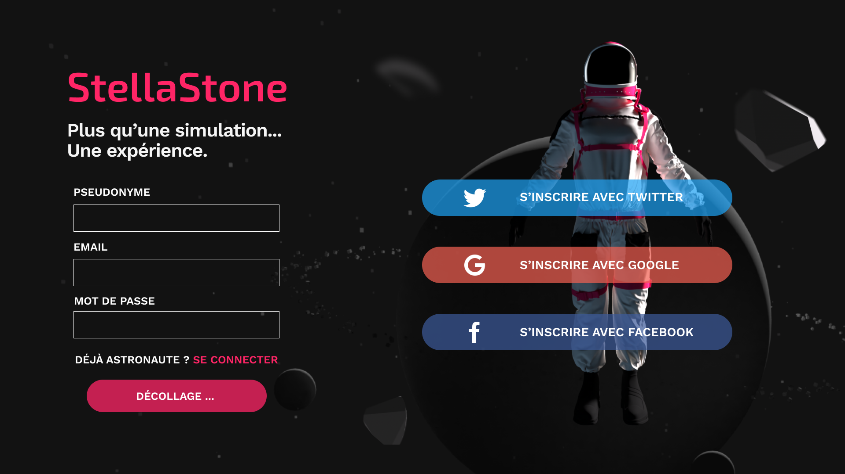

Figure 1: A000-0

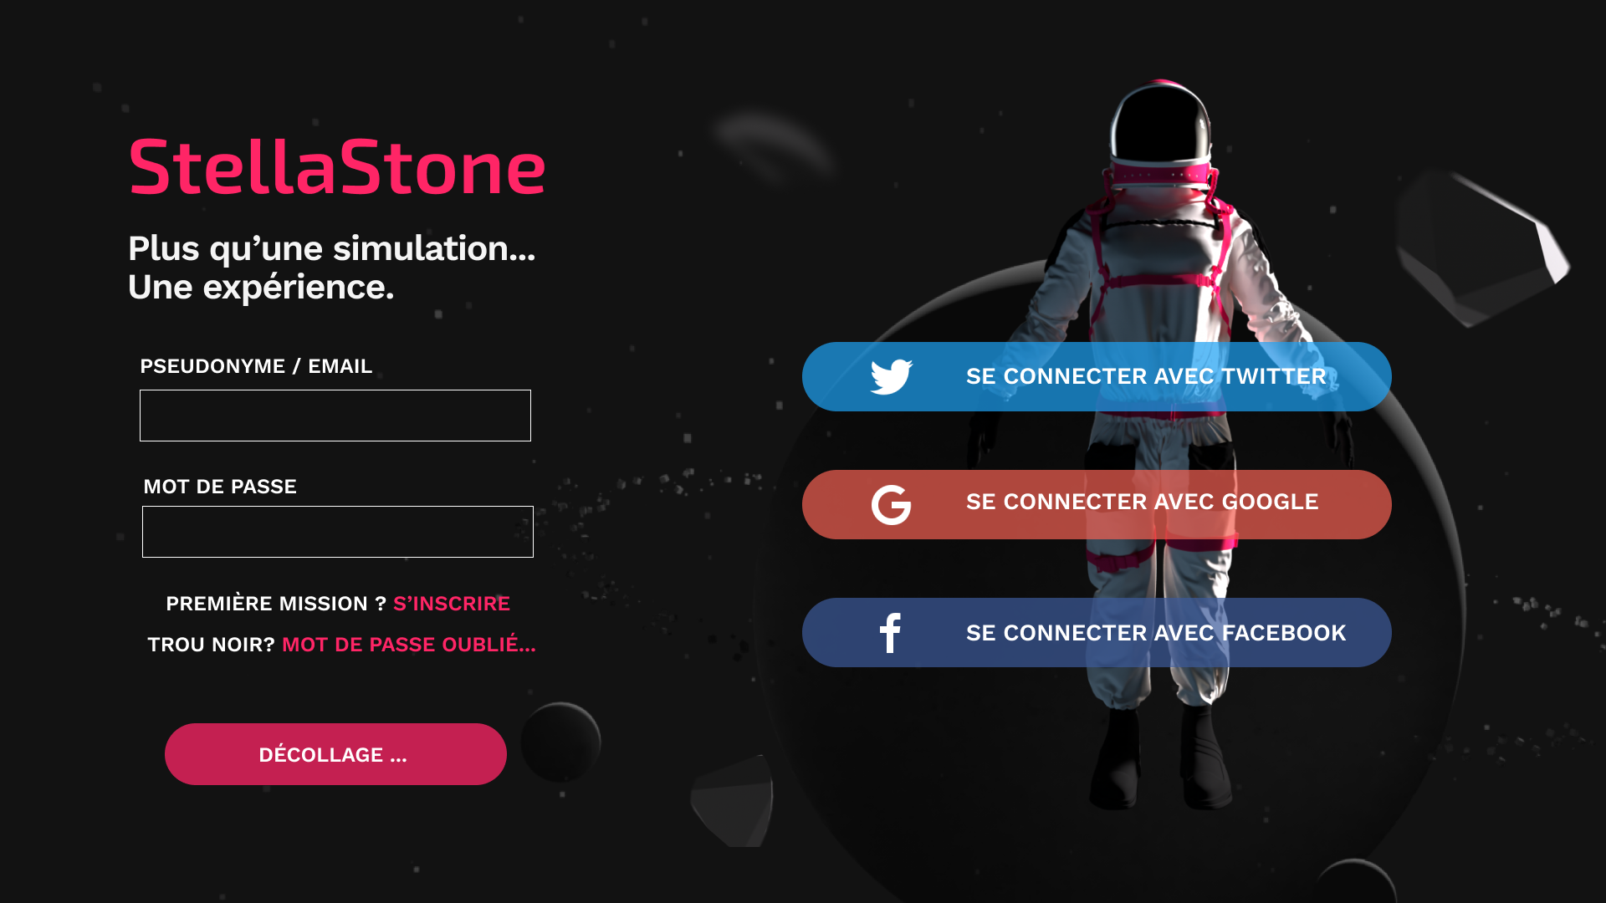

Figure 2: A000-1

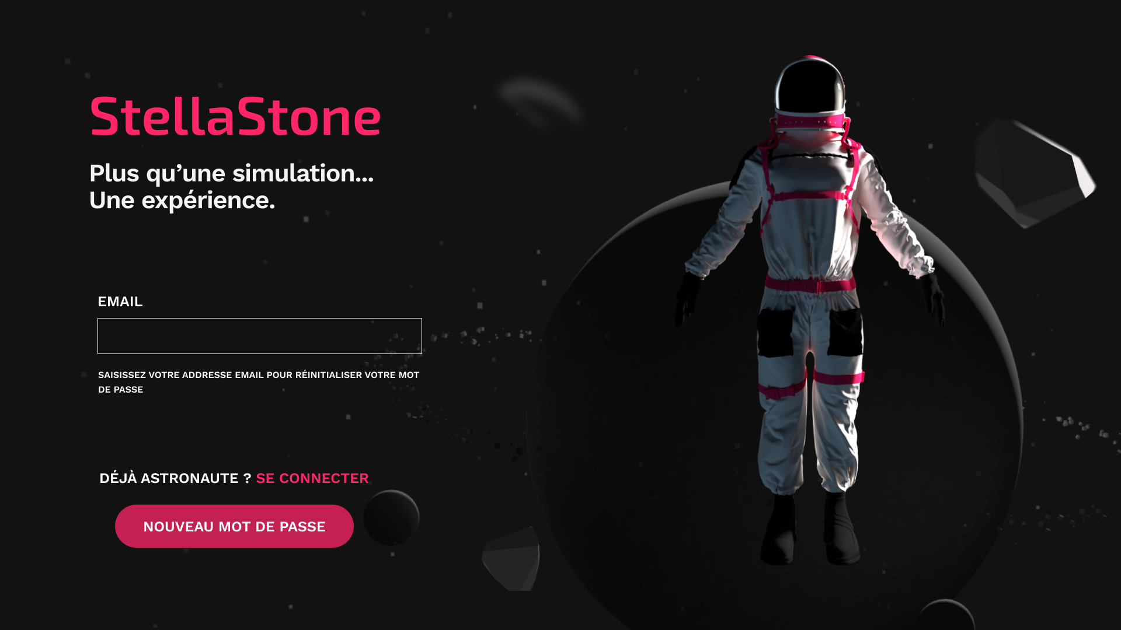

Figure 3: A000-2

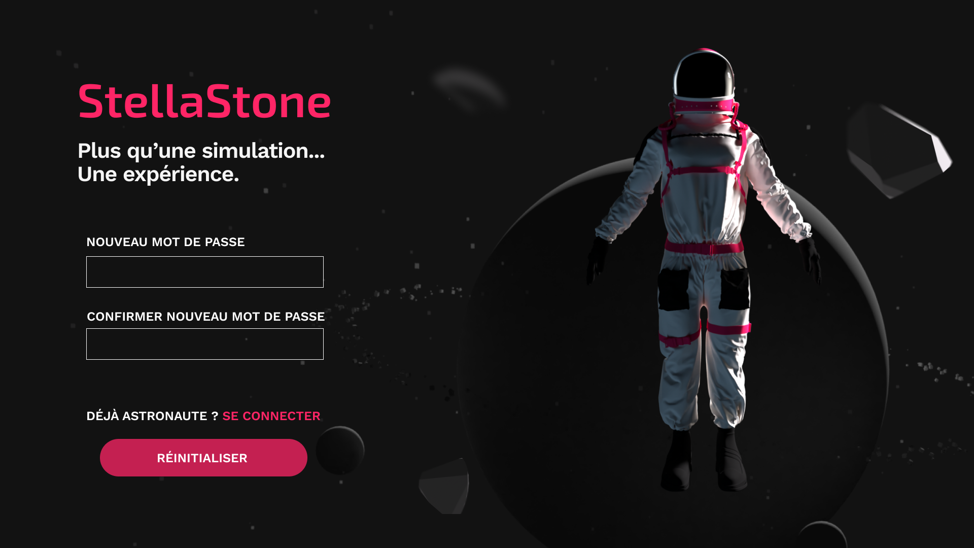

Figure 4: A000-3

# accueil

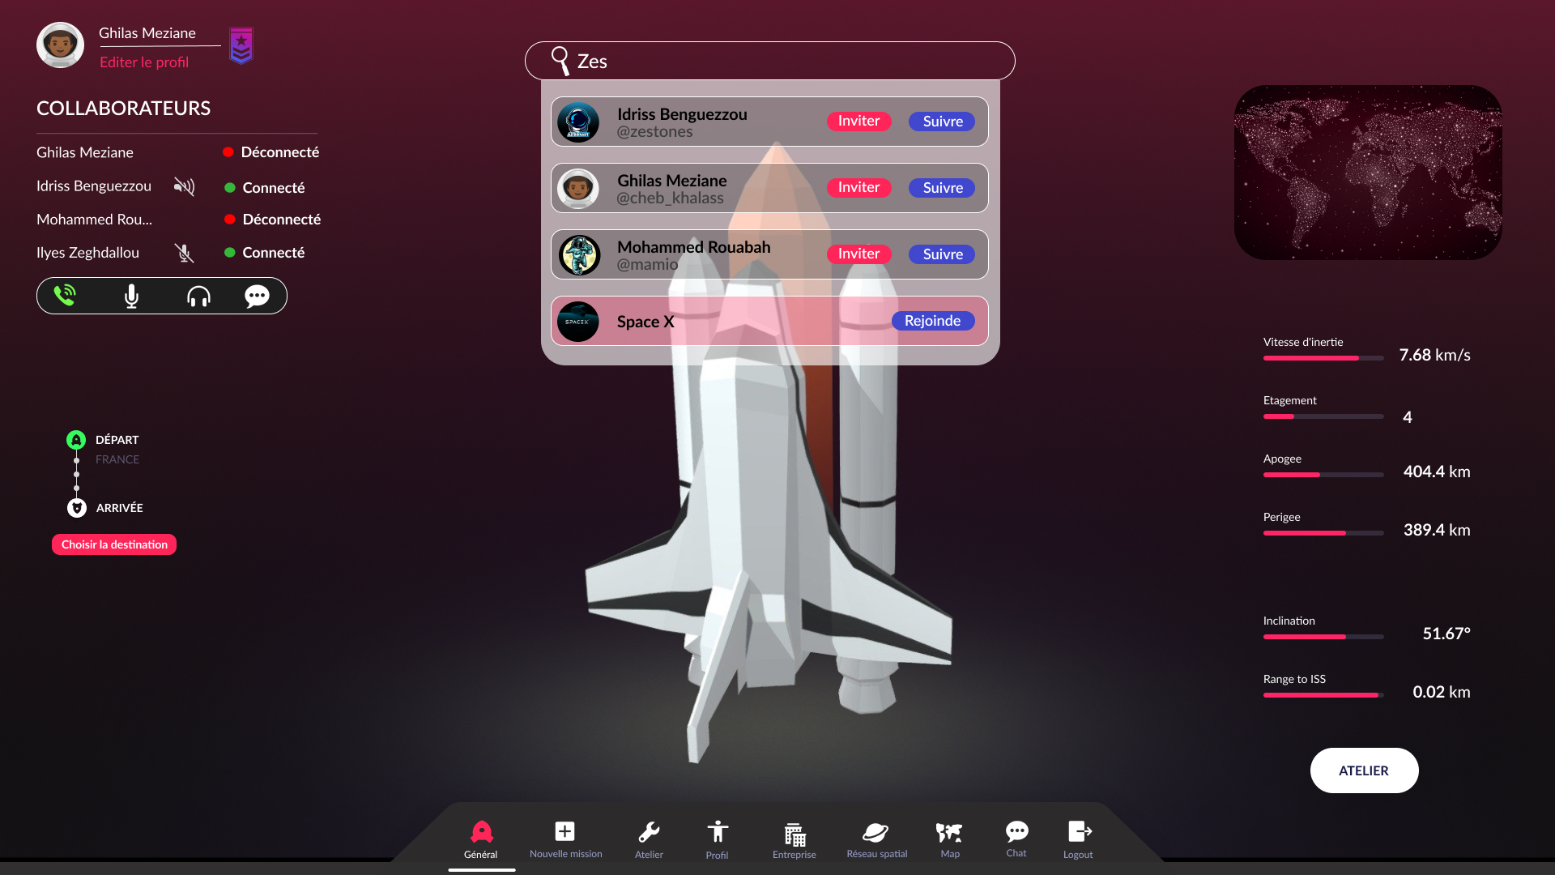

Figure 5: H000-0

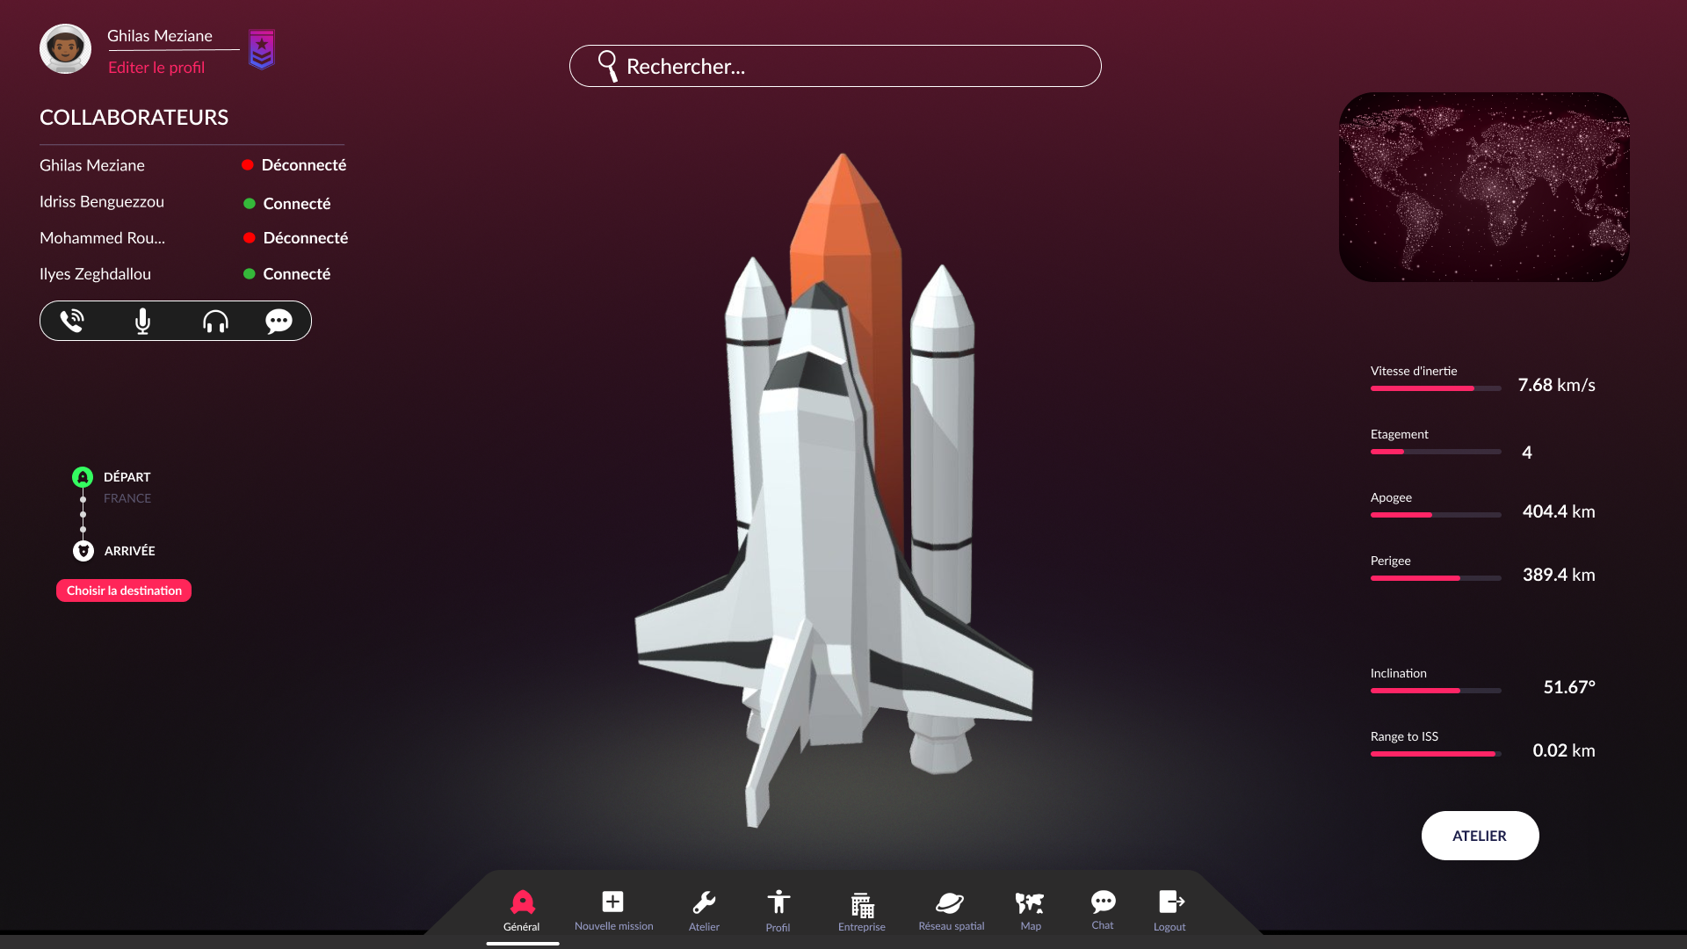

Figure 6: H001-0

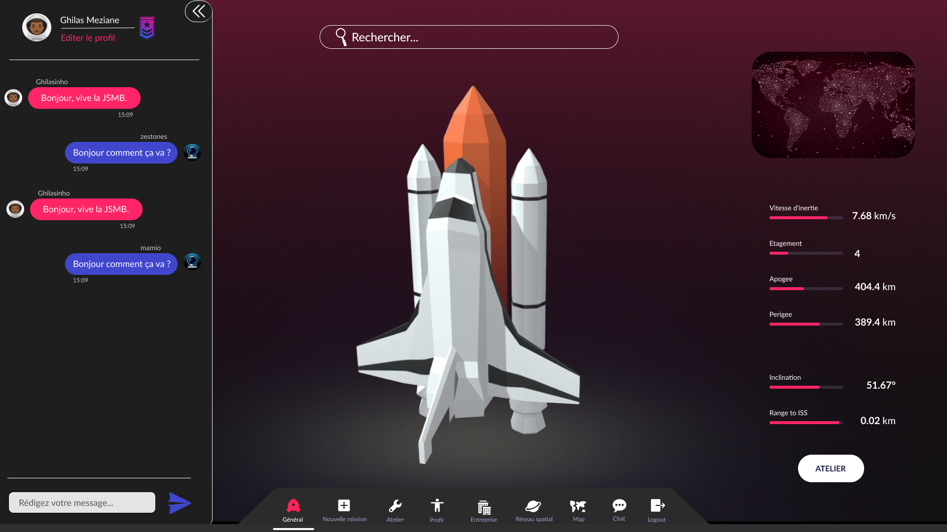

Figure 7: H001-1

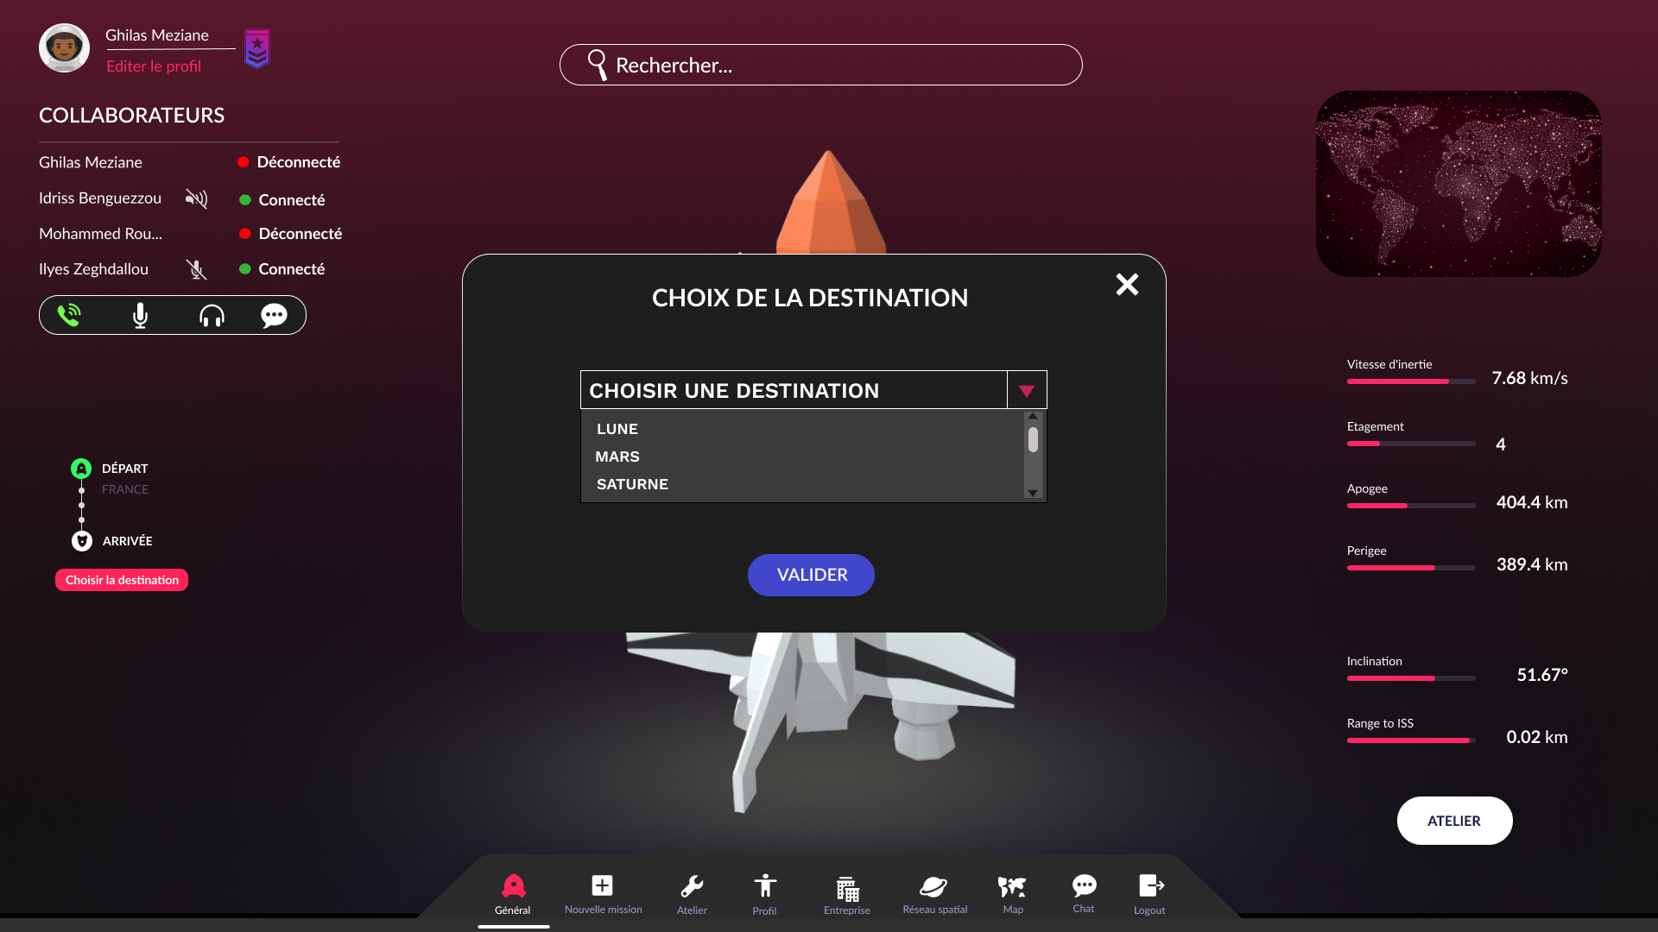

Figure 8: H002-0

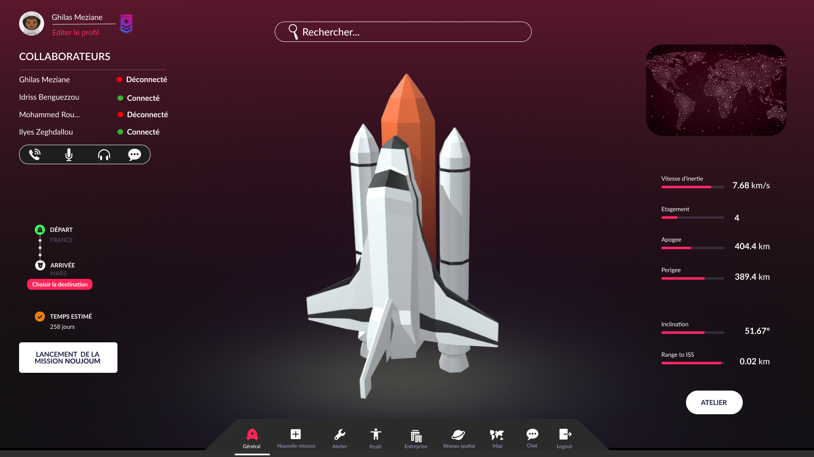

Figure 9: H002-1

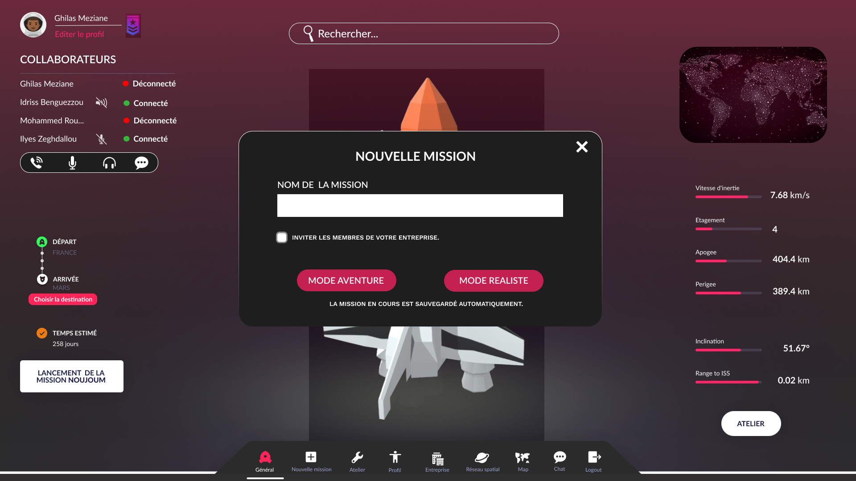

Figure 10: H003-0

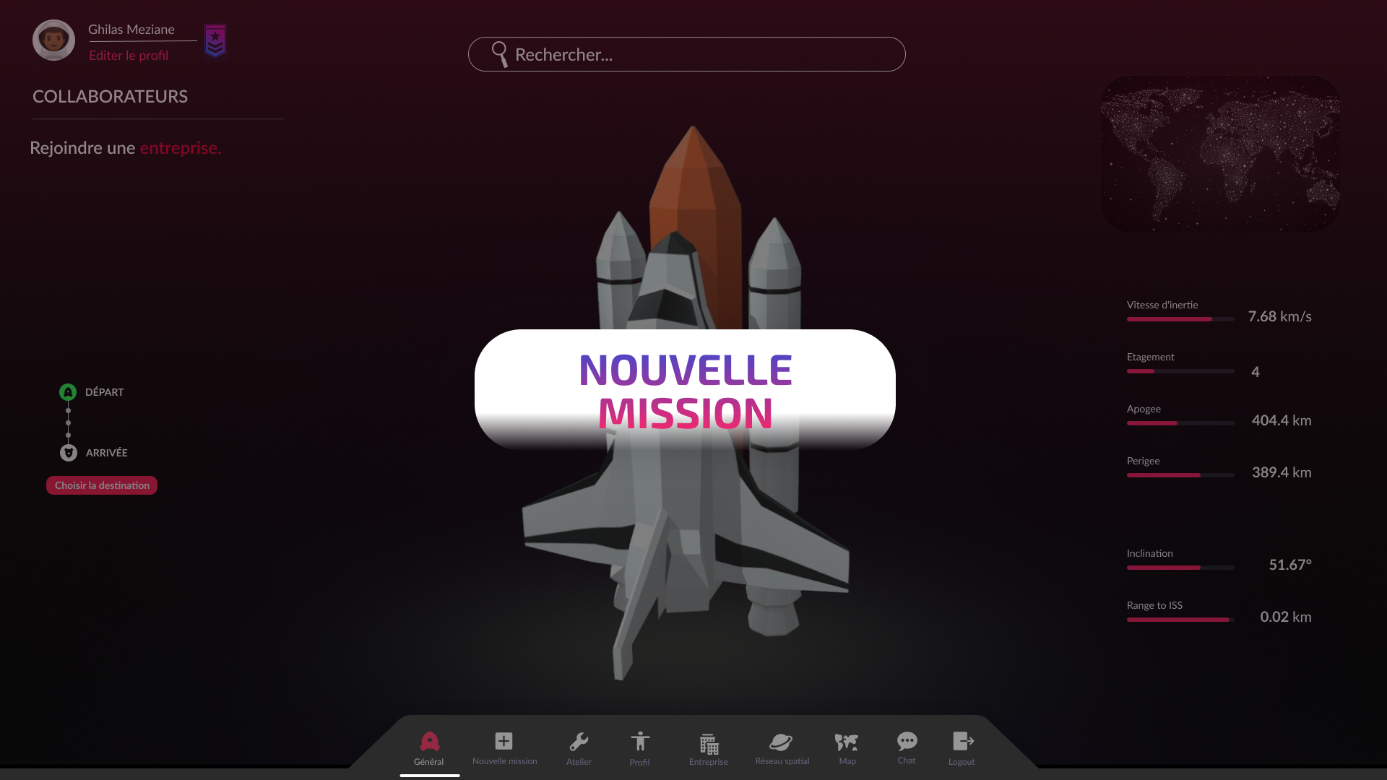

Figure 11: H004-0

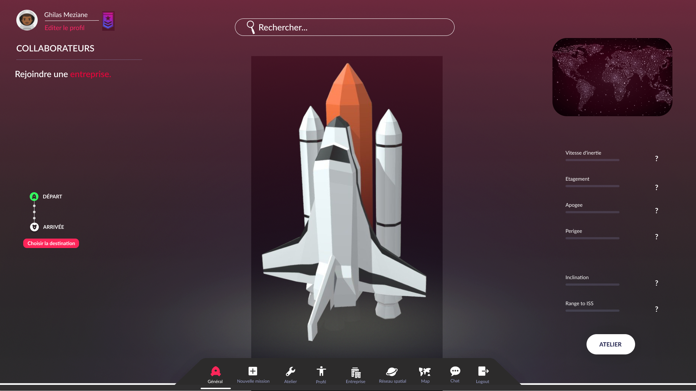

Figure 12: H005-0



Figure 13: H005-1

# Profil

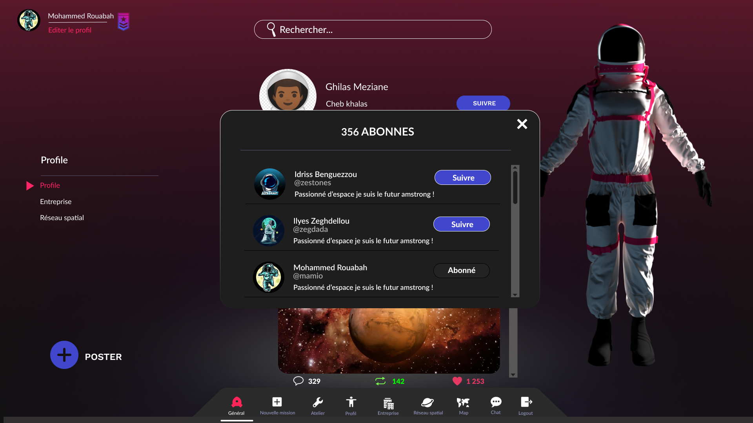

Figure 14: P001-0

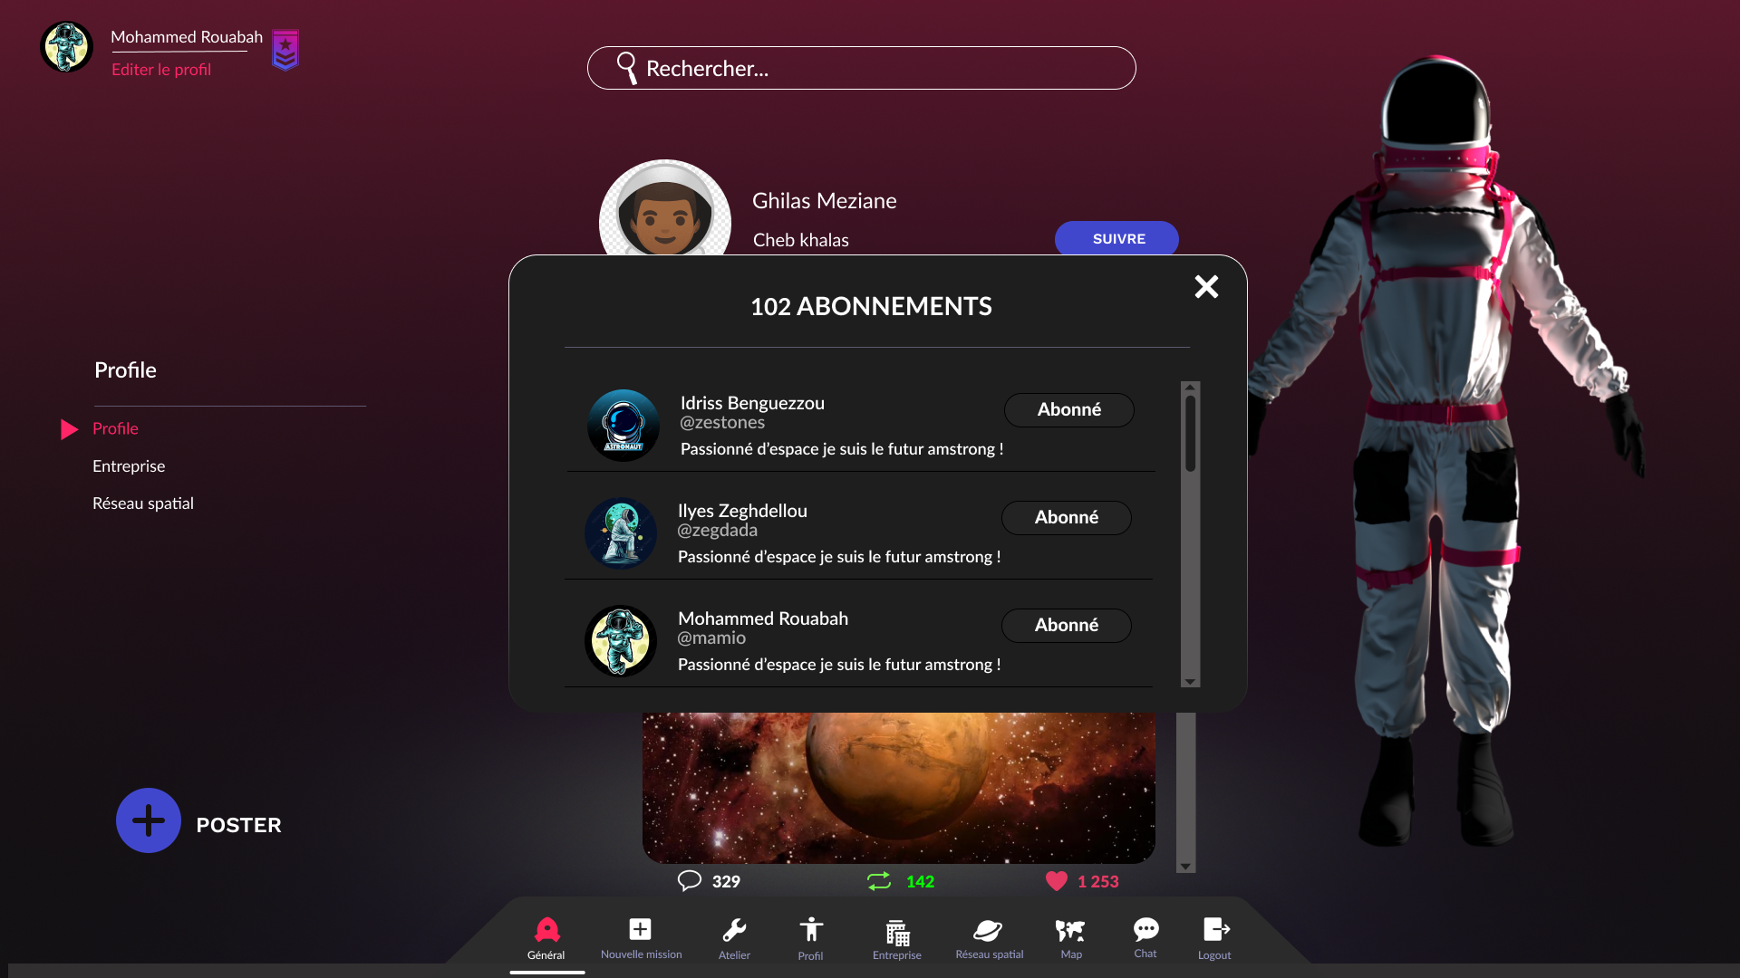

Figure 15: P001-1

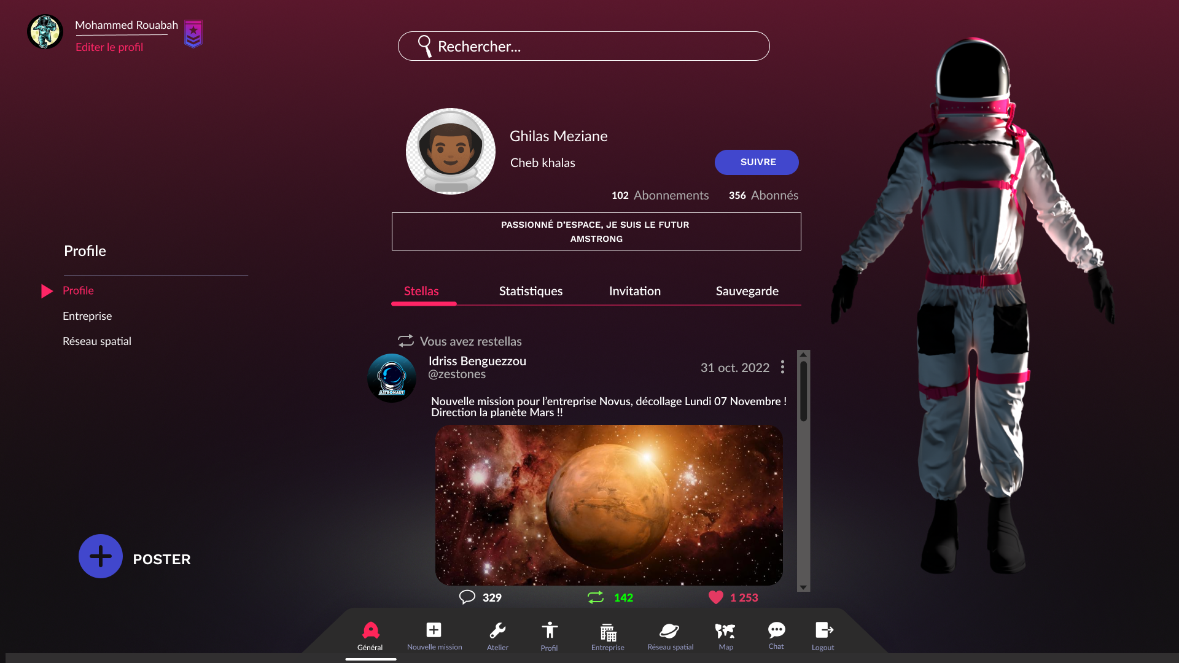

Figure 16: P002-0

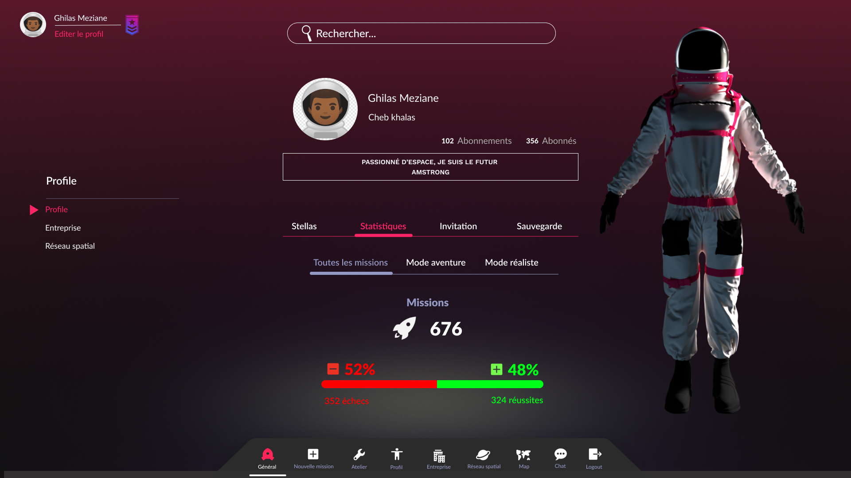

Figure 17: P003-0

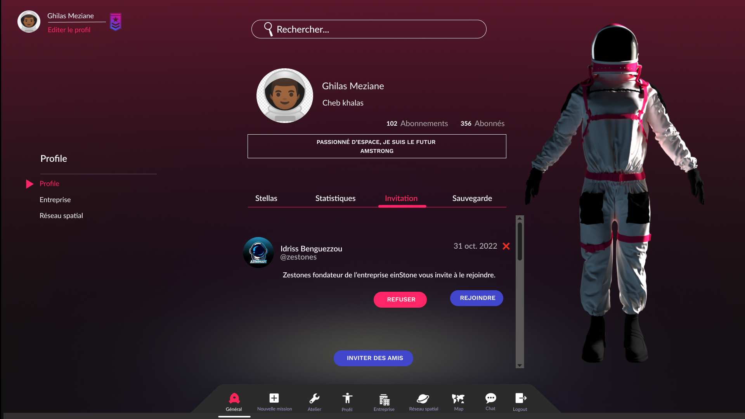

Figure 18: P004-0

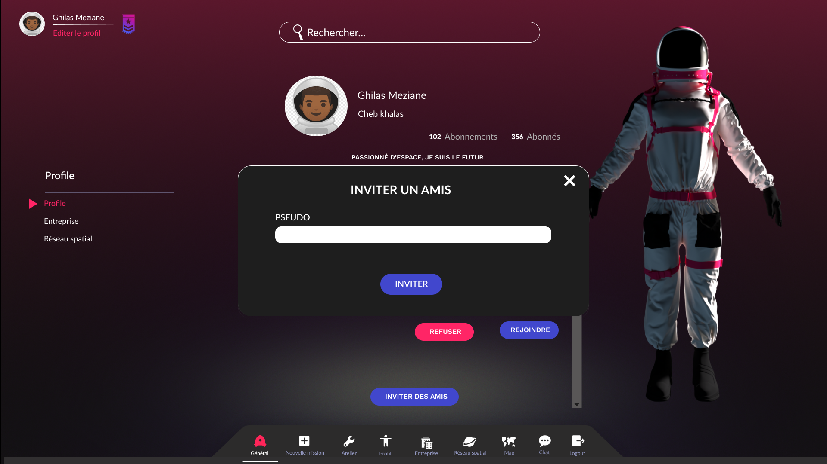

Figure 19: P004-1

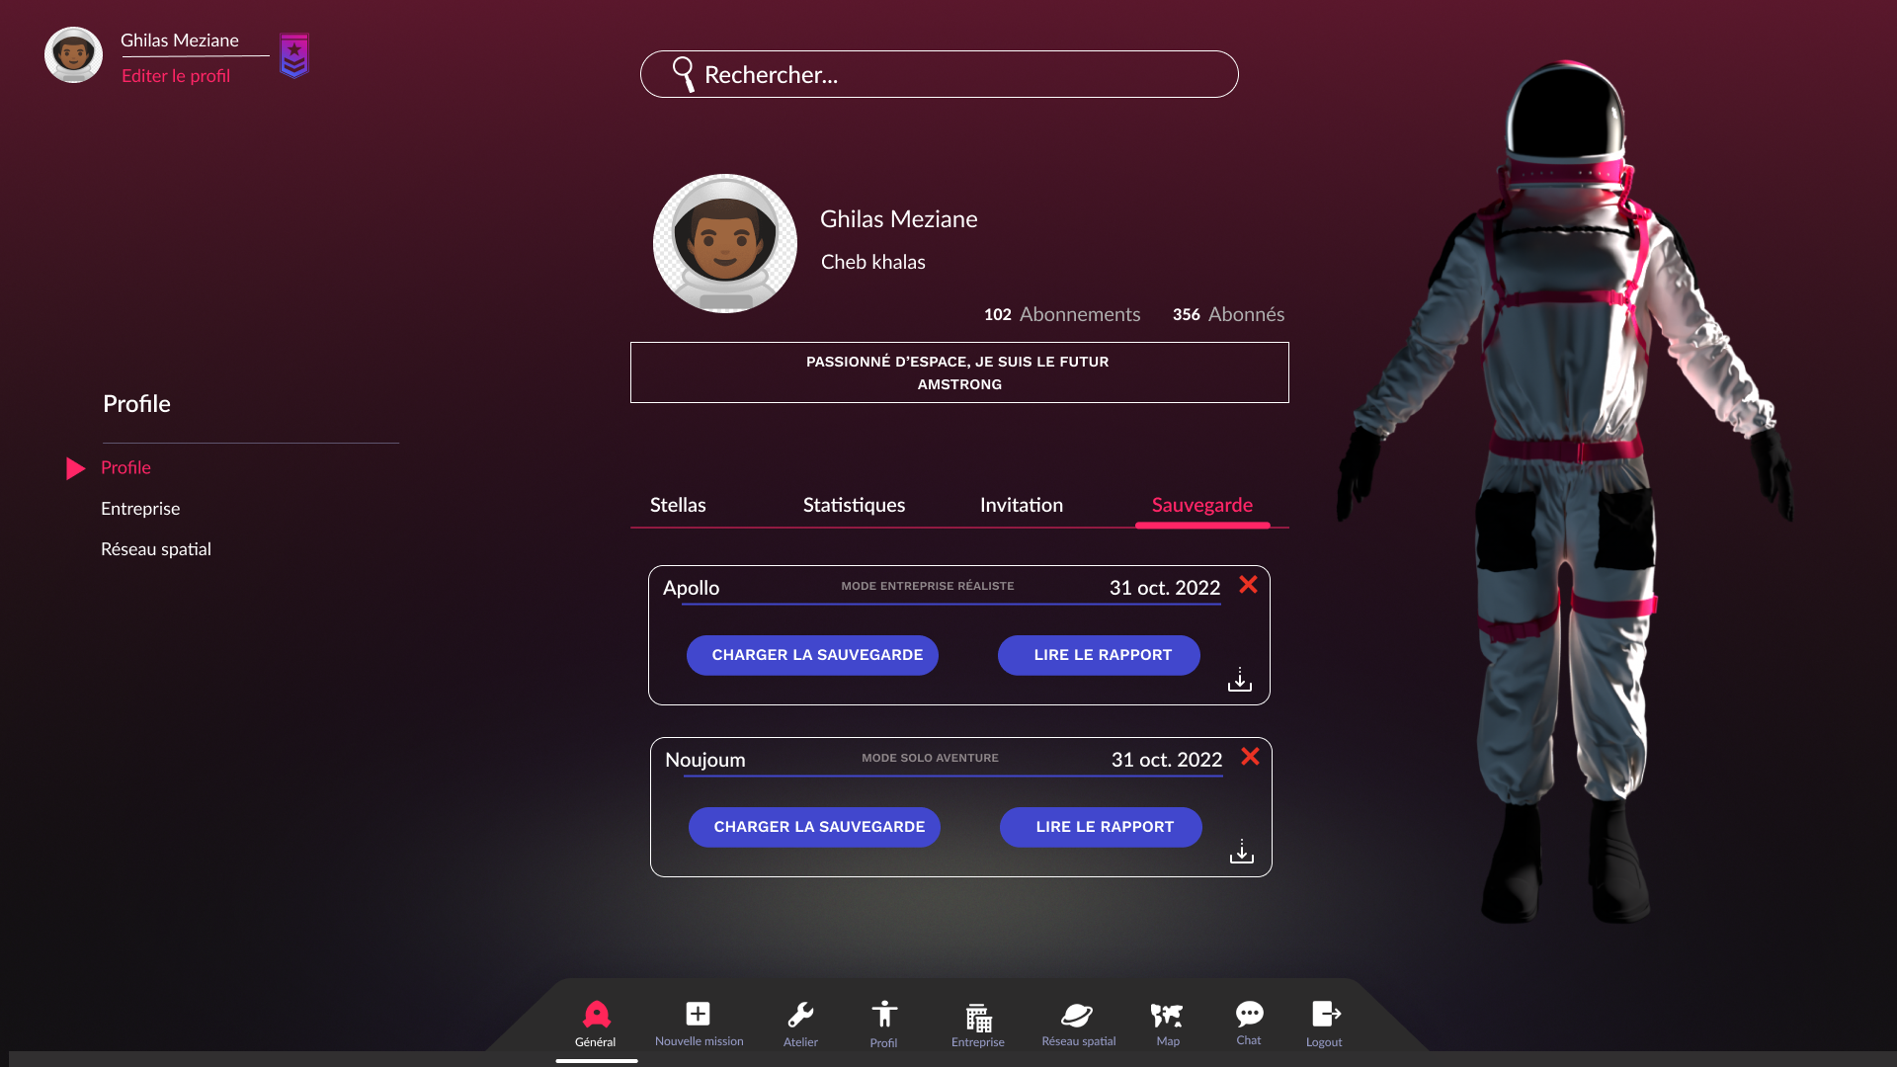

Figure 20: P005-0

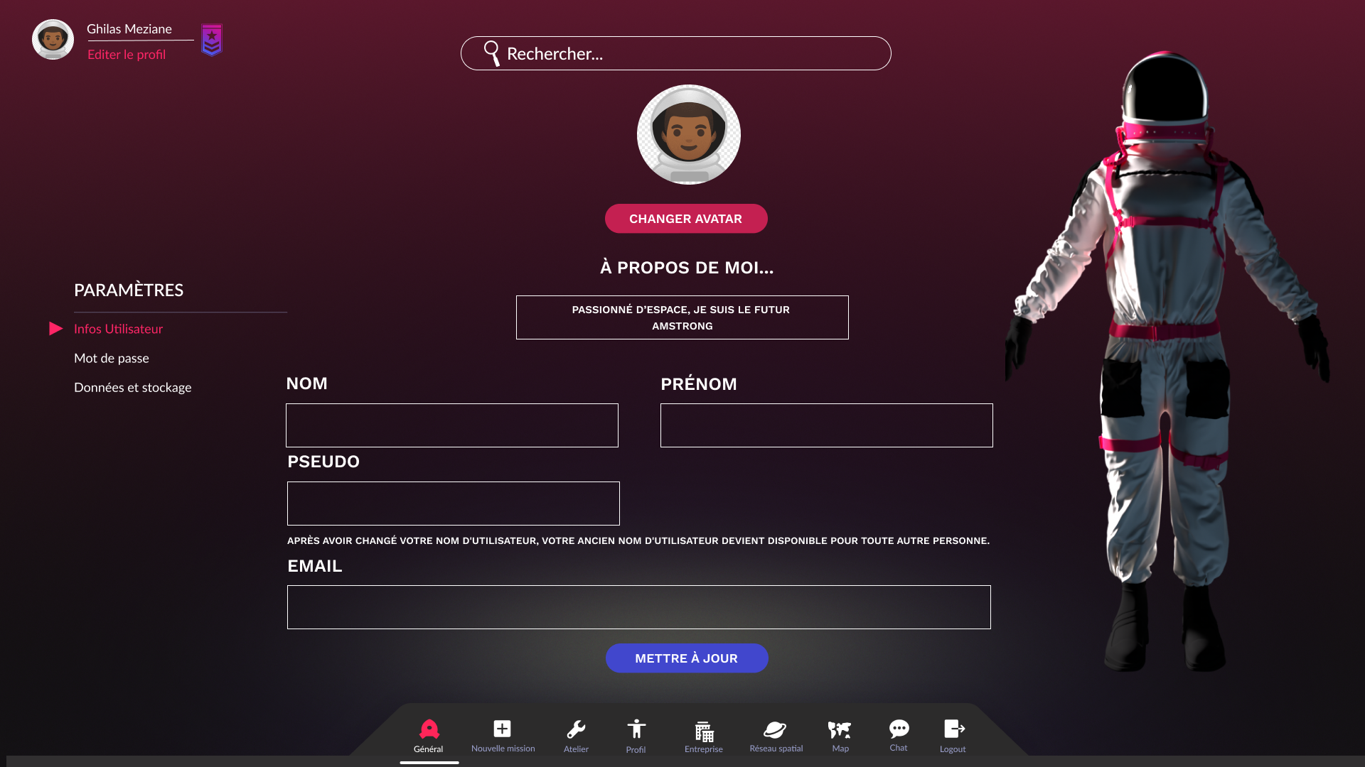

Figure 21: P006-0

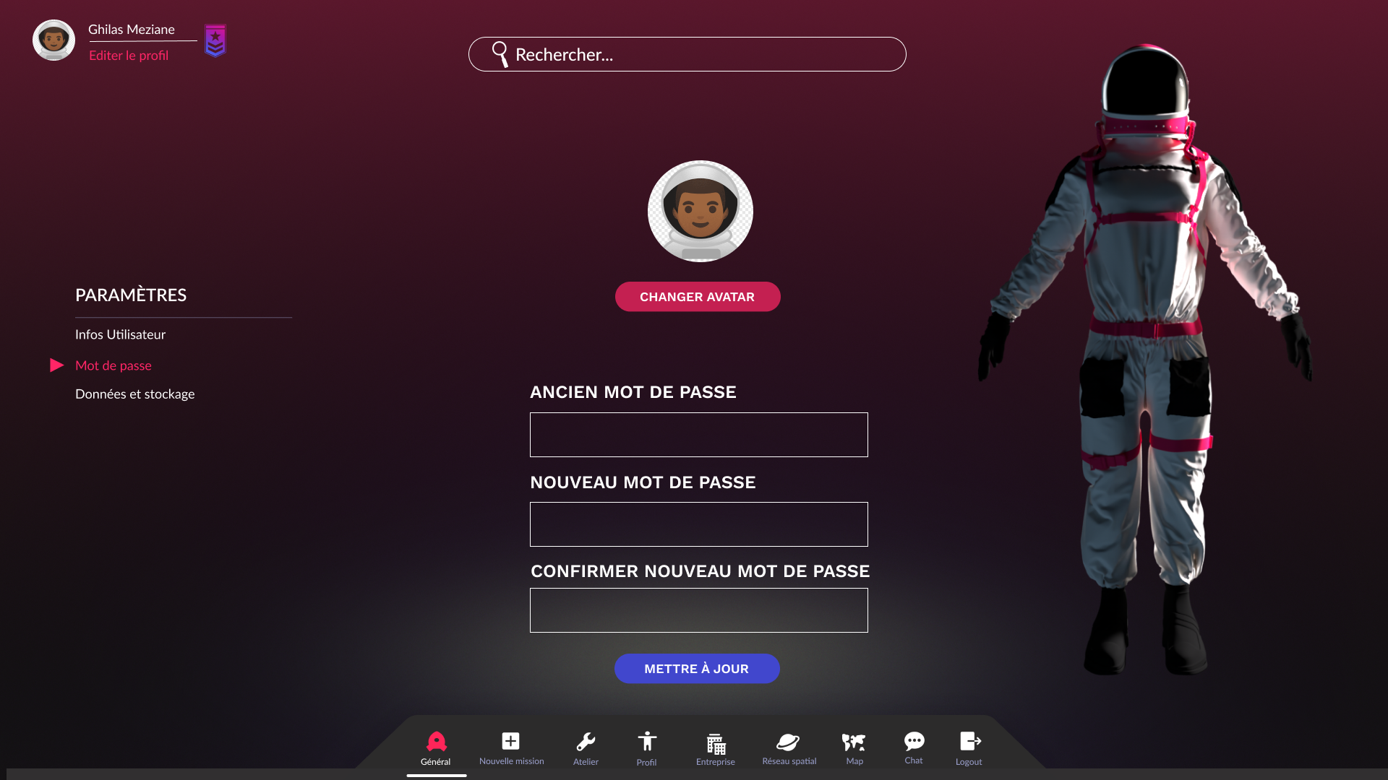

Figure 22: P007-0

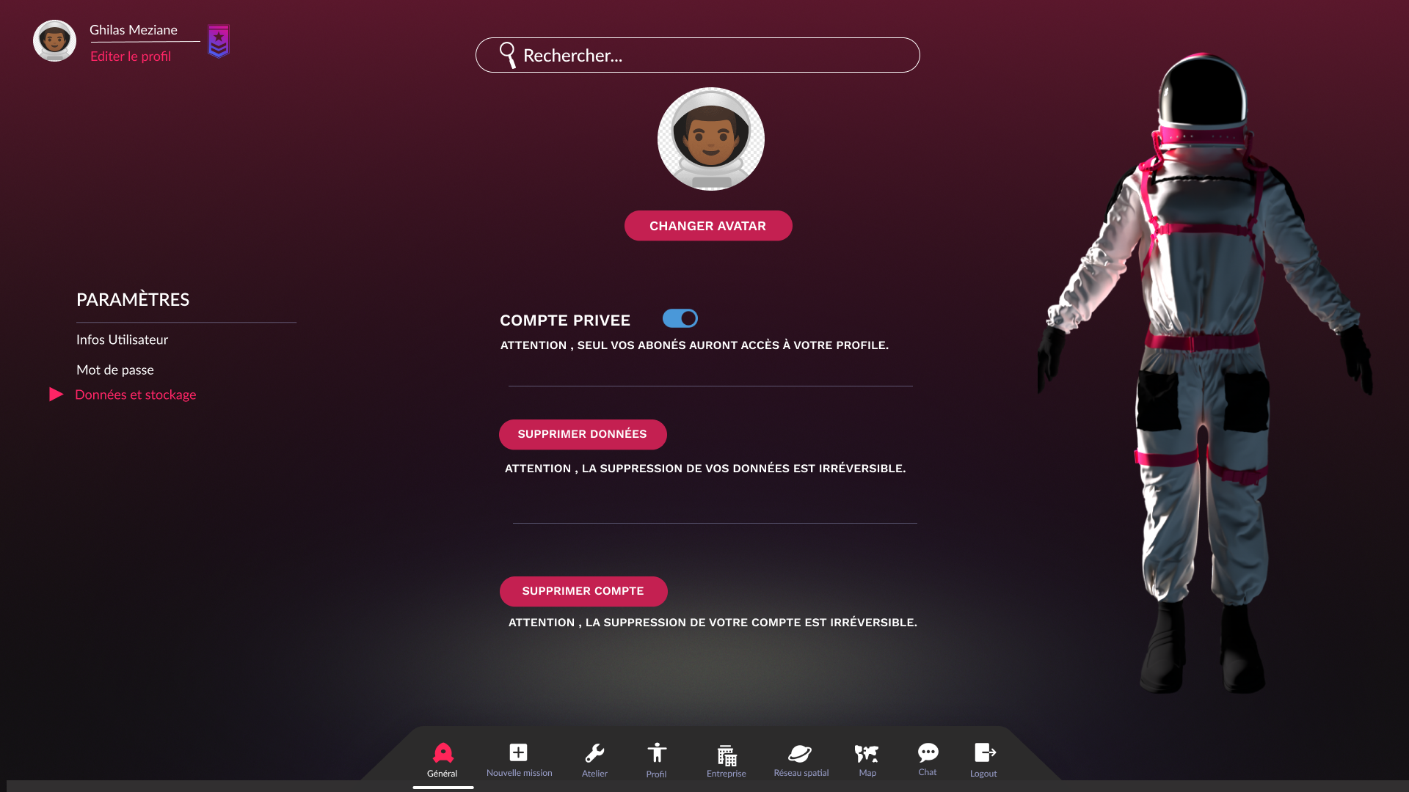

Figure 23: P008-0

# Entreprise

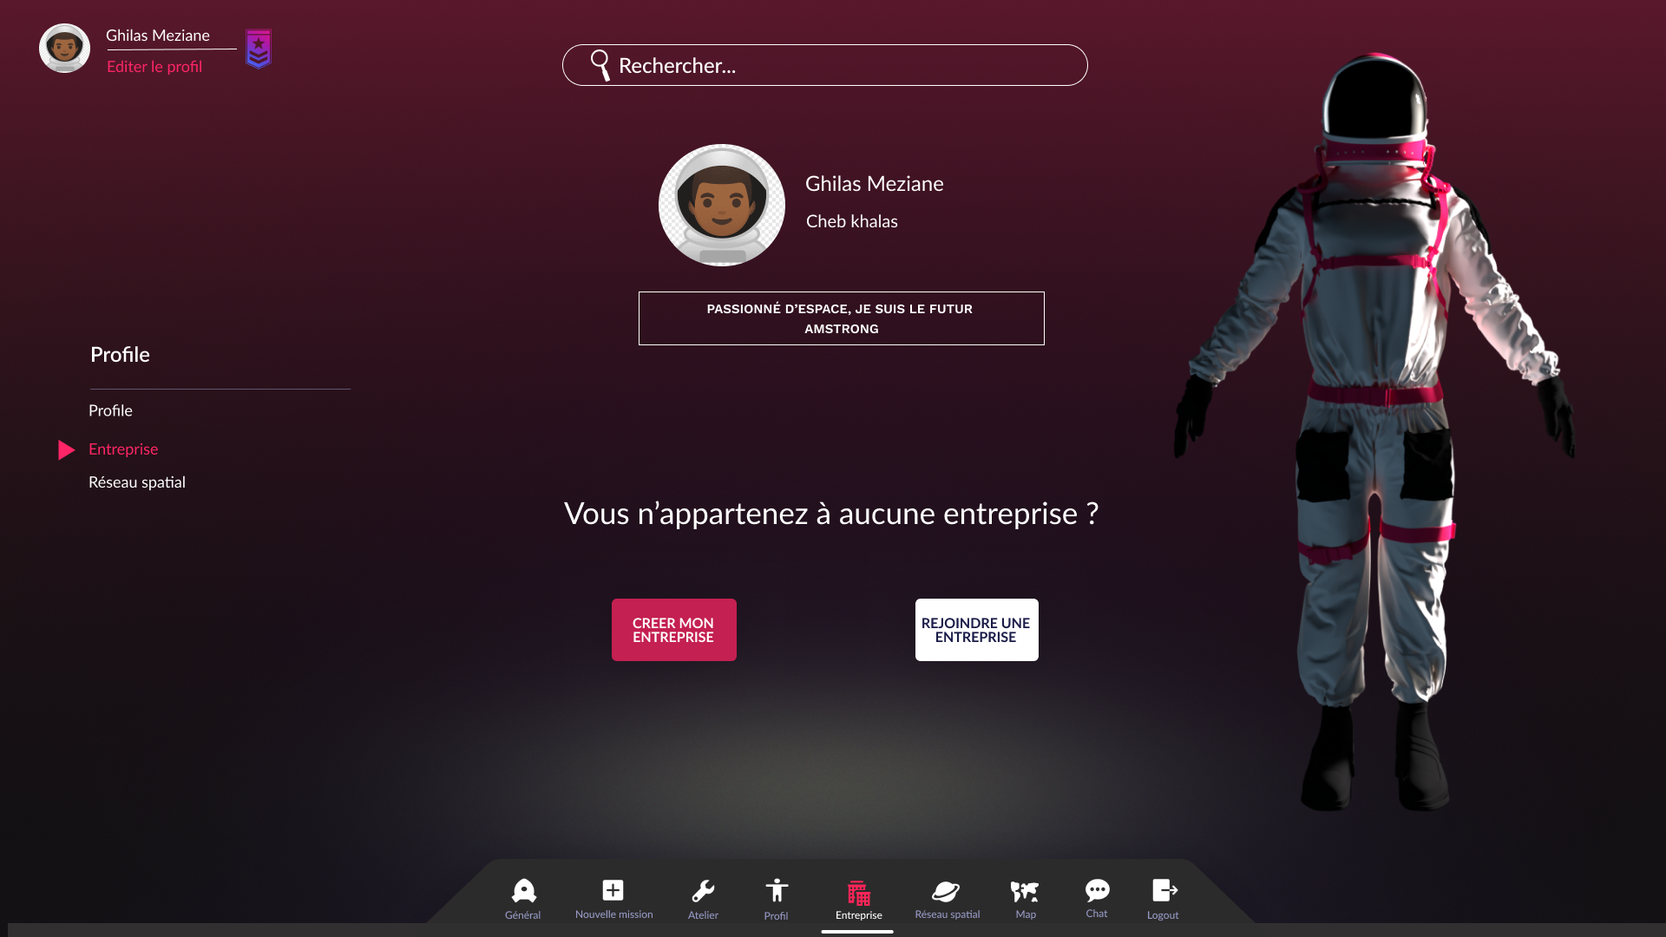

Figure 24: E000-0

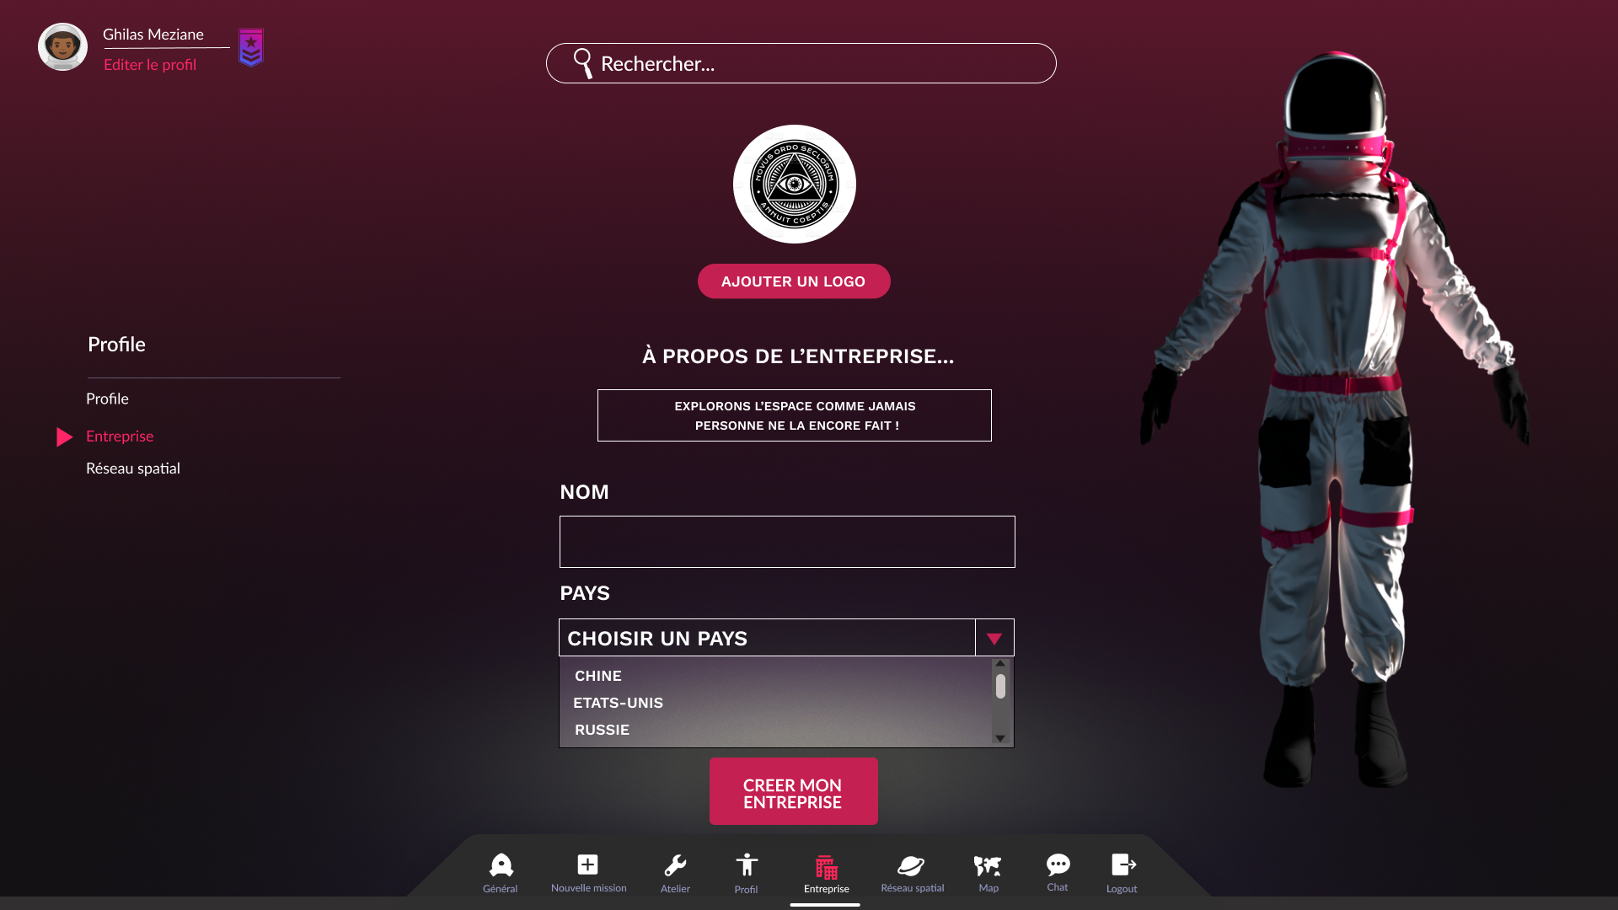

Figure 25: E001-0

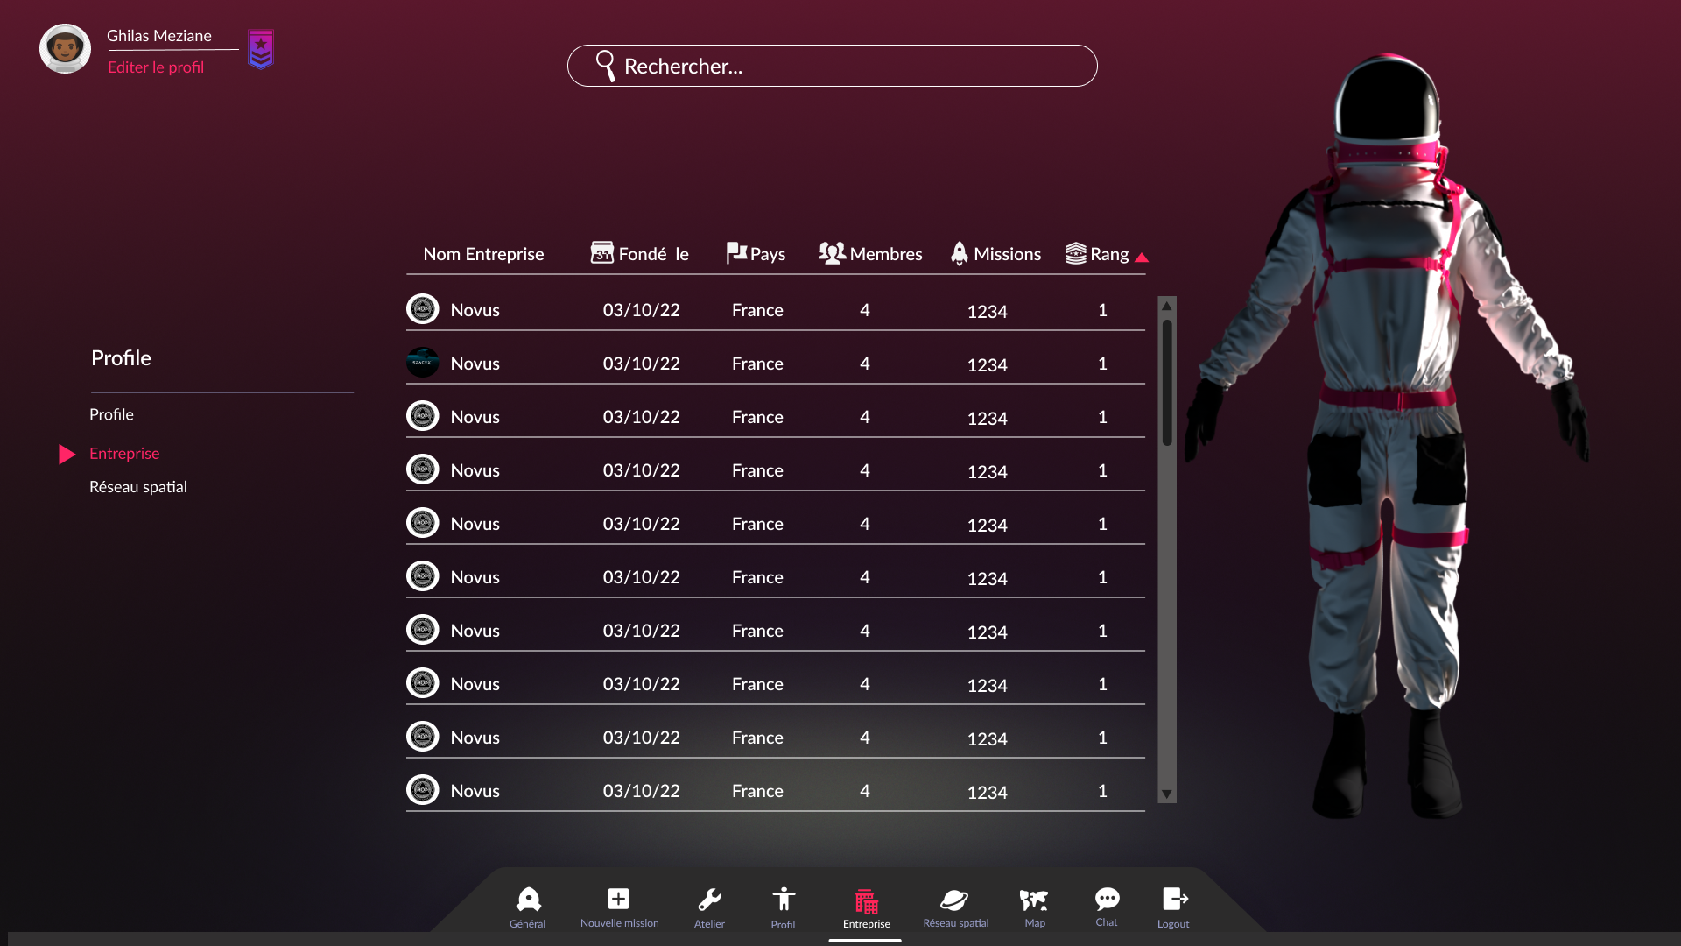

Figure 26: E002-0

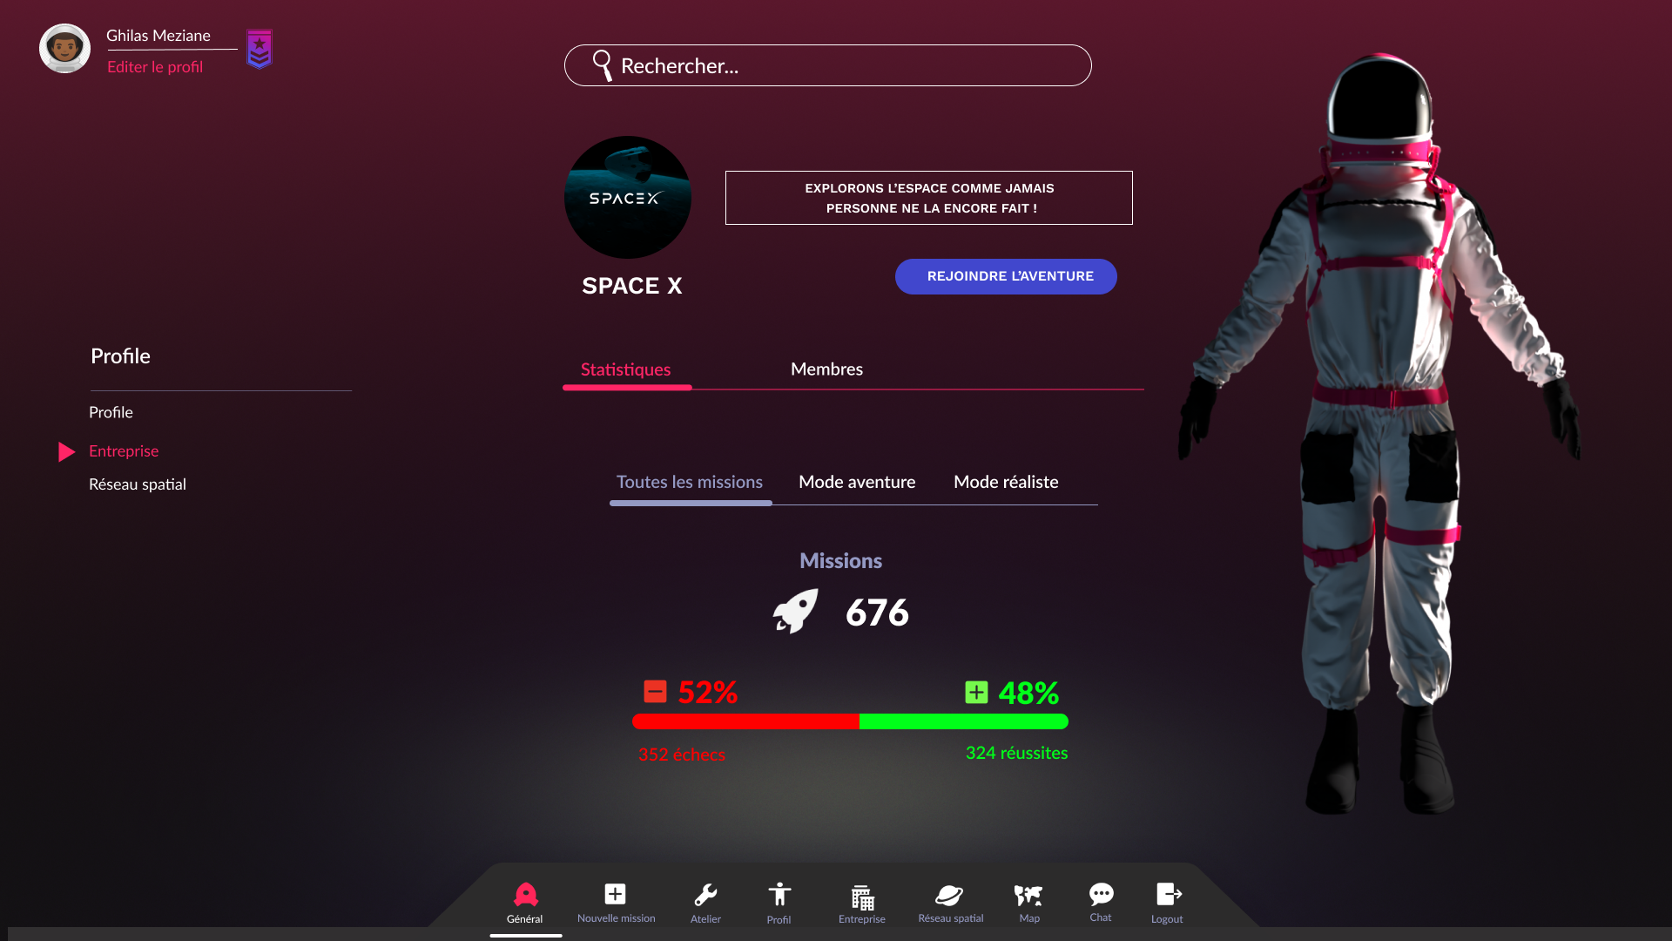

Figure 27: E003-0

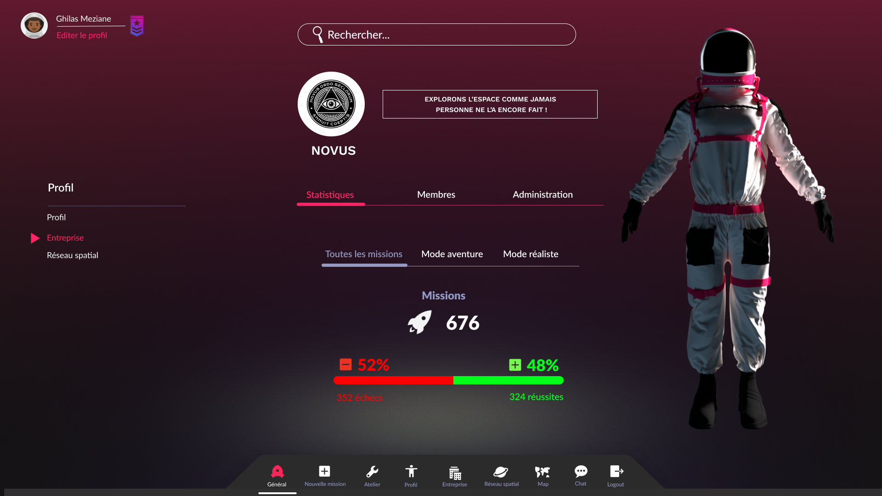

Figure 28: E004-0

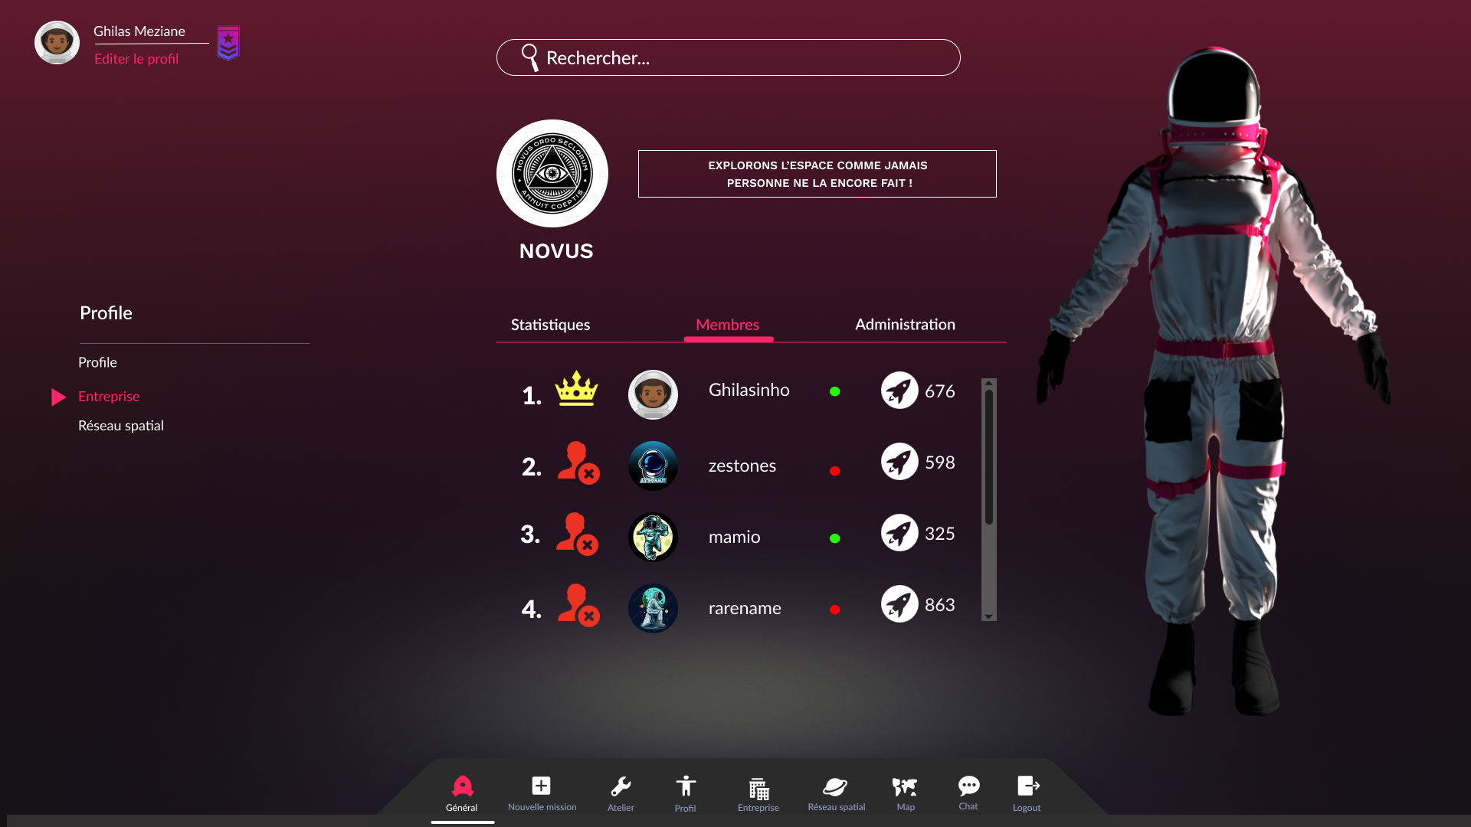

Figure 29: E004-1

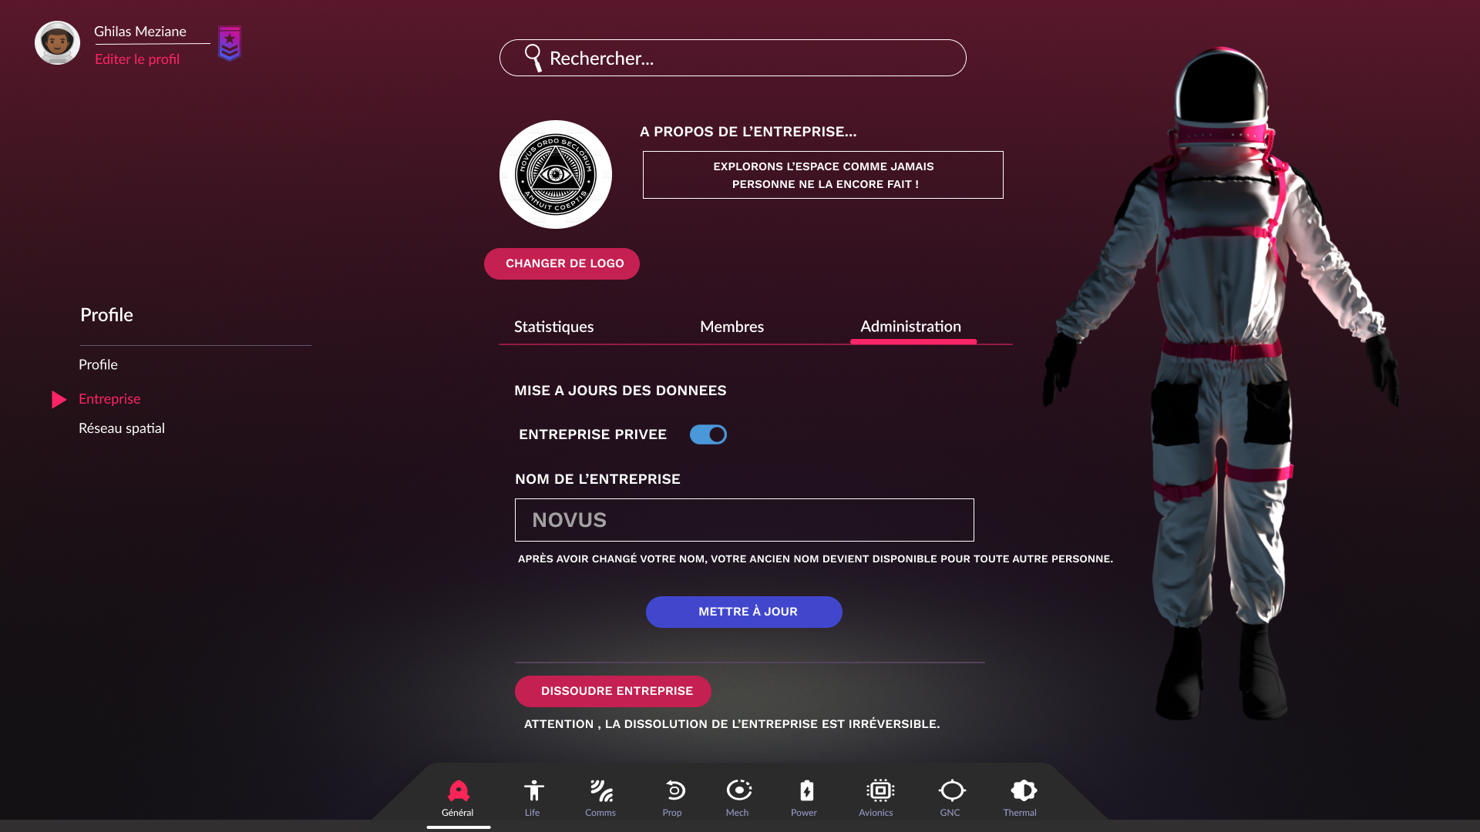

Figure 30: E005-0

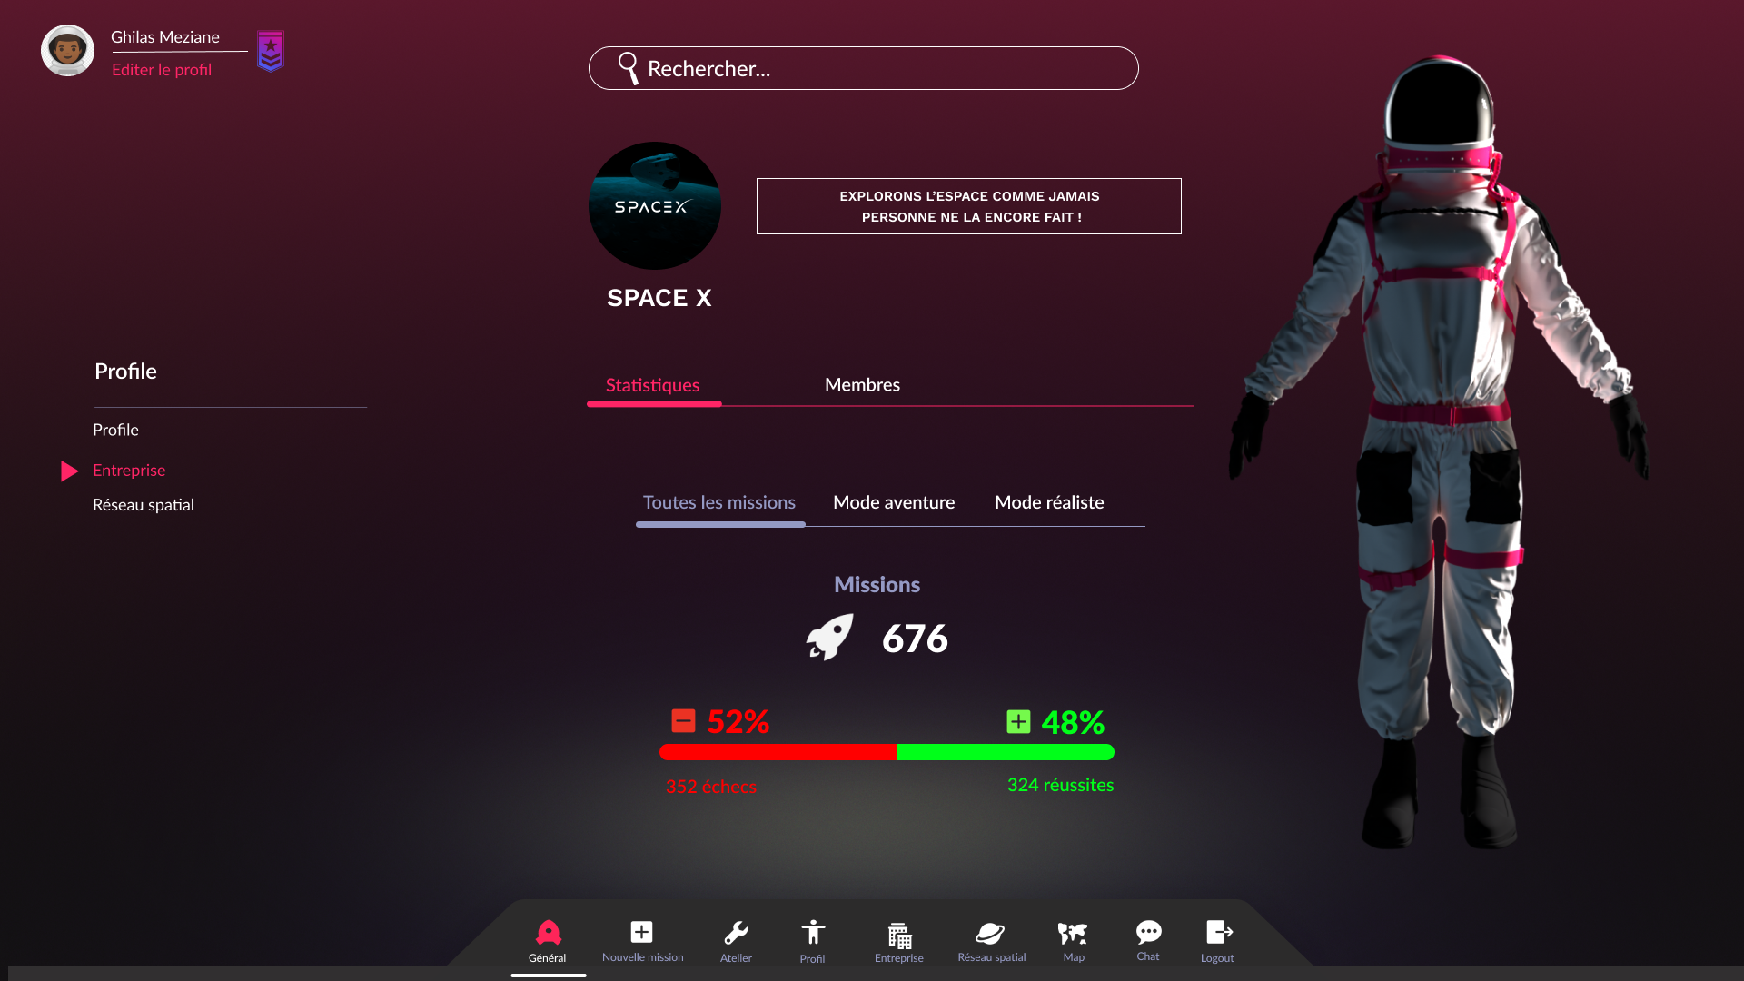

Figure 31: E005-1

# Reseau spatial

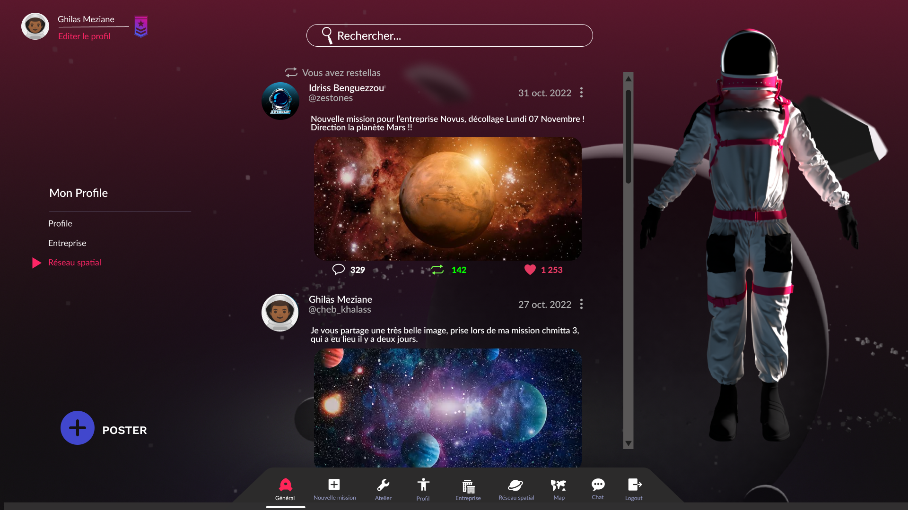

Figure 32: R000-0

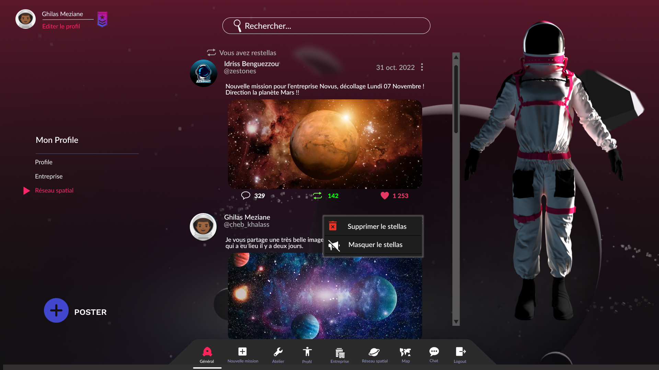

Figure 33: R001-0

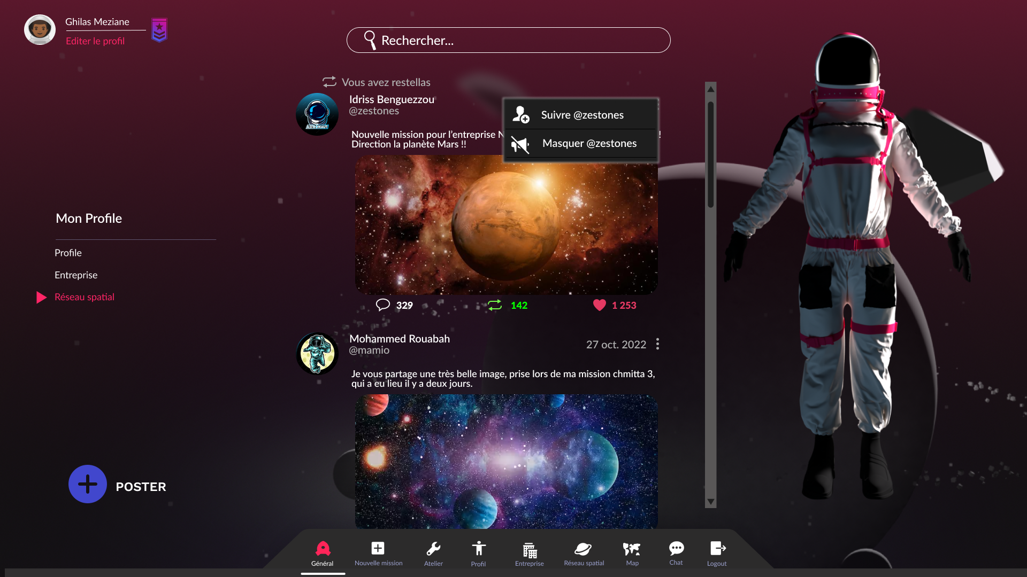

Figure 34: R001-1

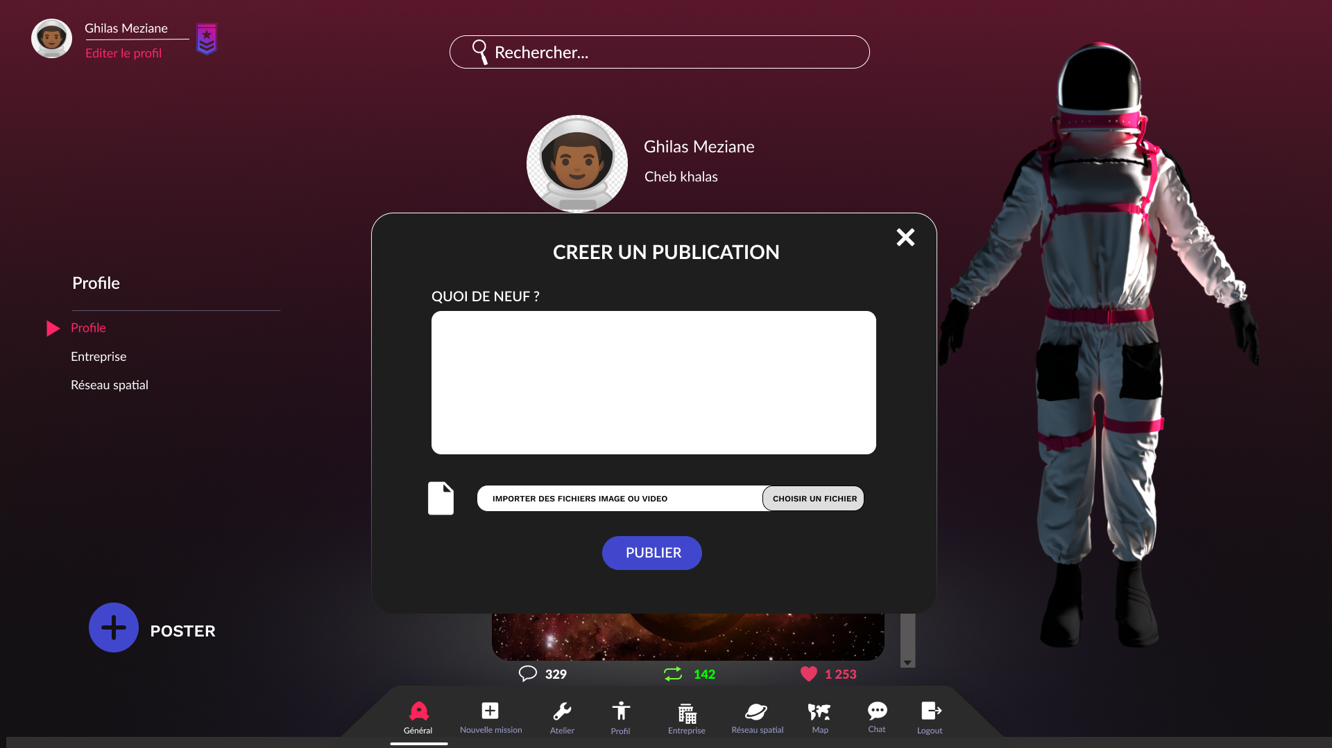

Figure 35: R002-0

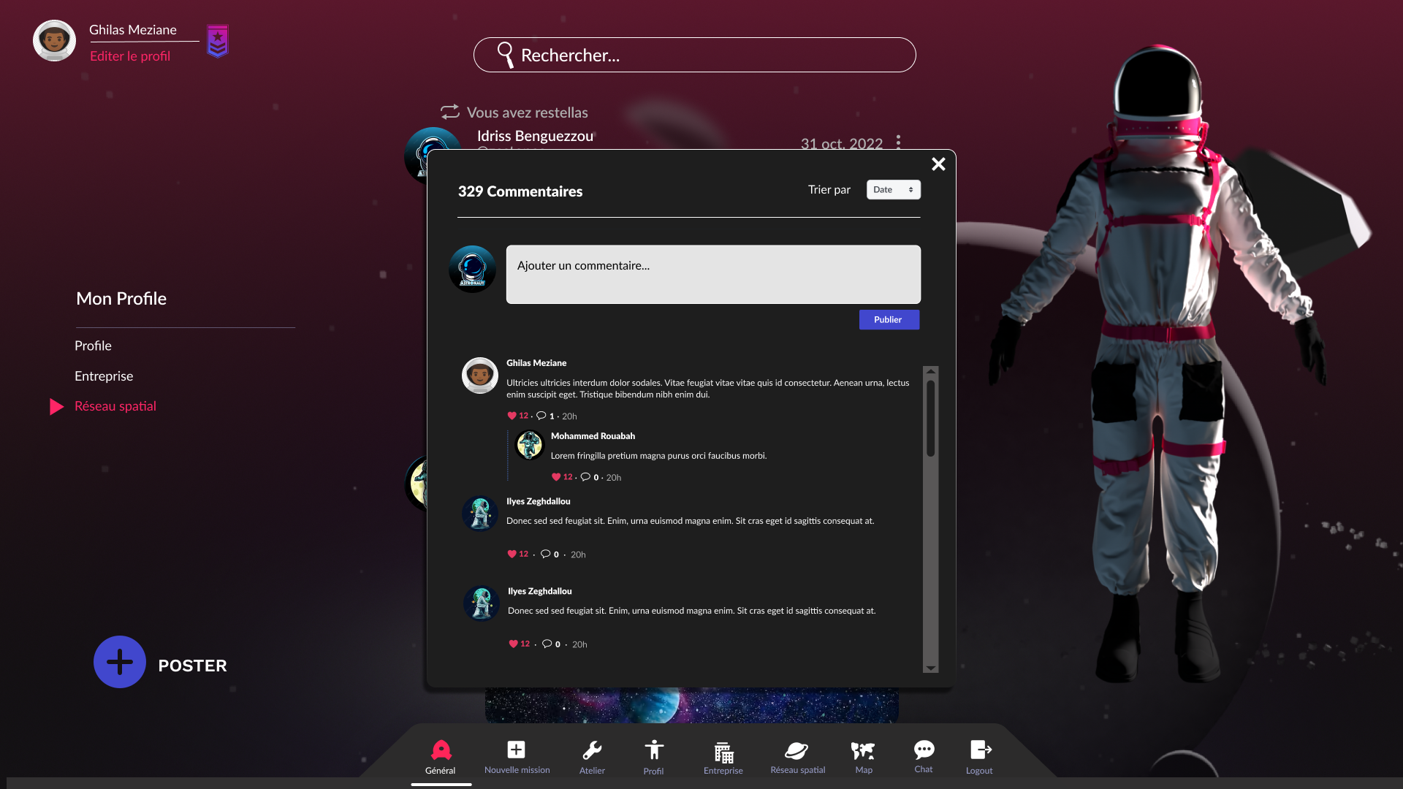

Figure 36: R003-0

# carte du monde

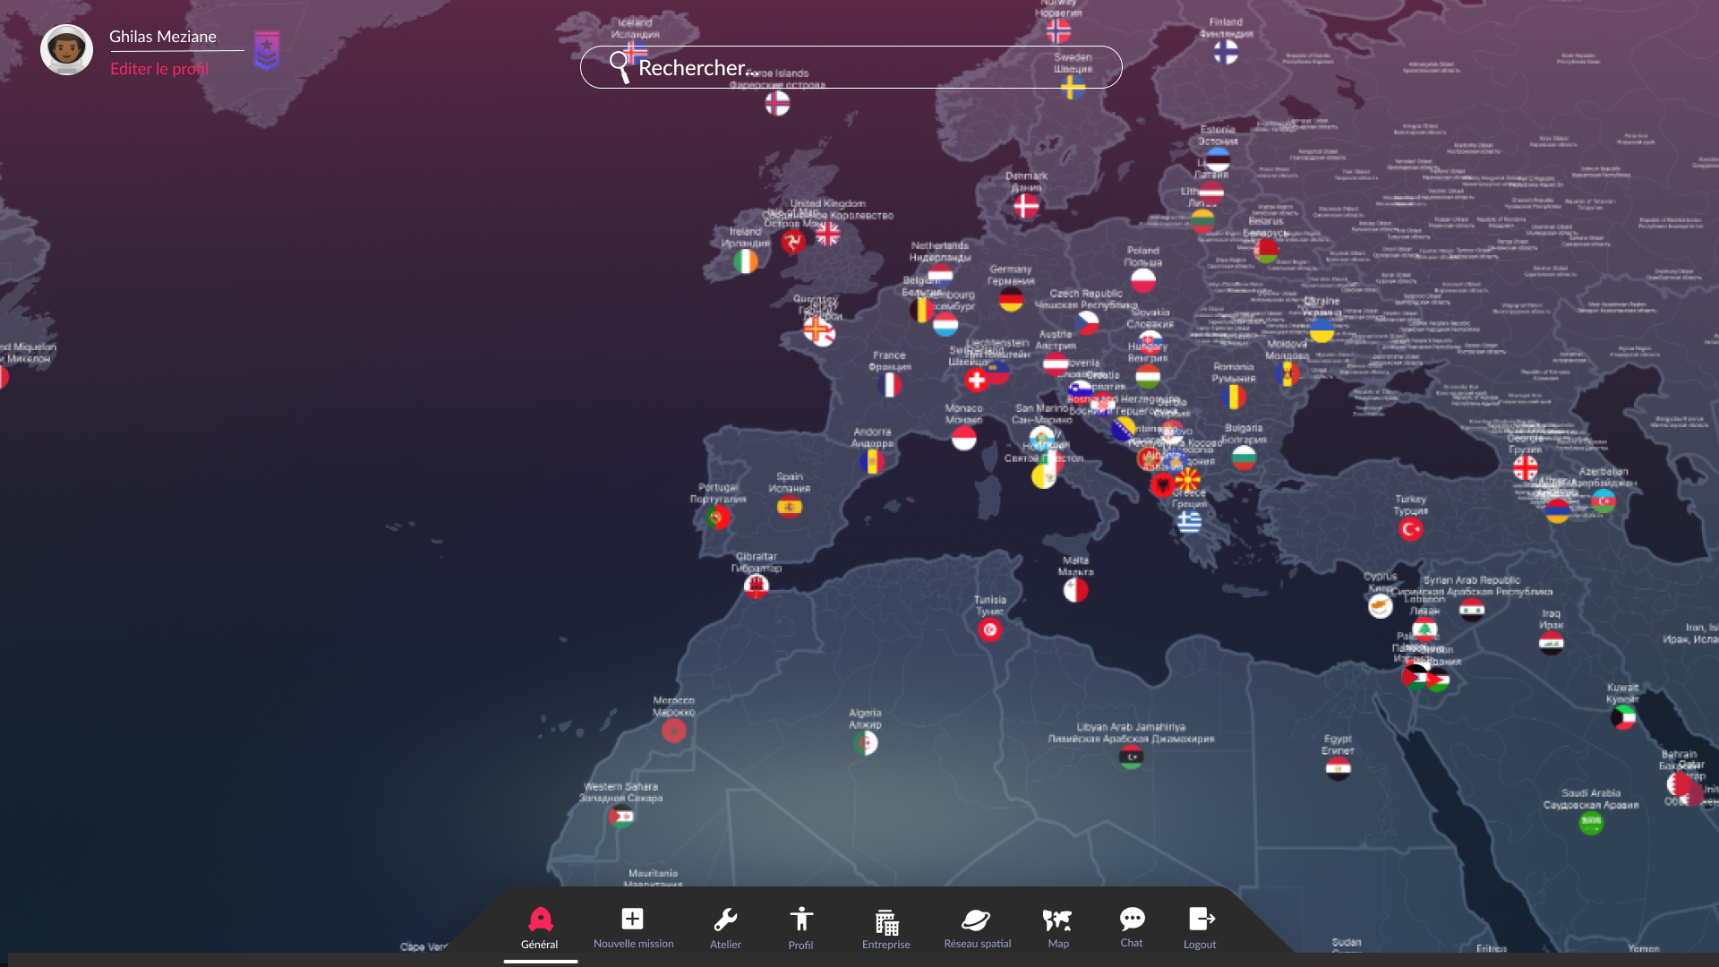

Figure 37: C000-0

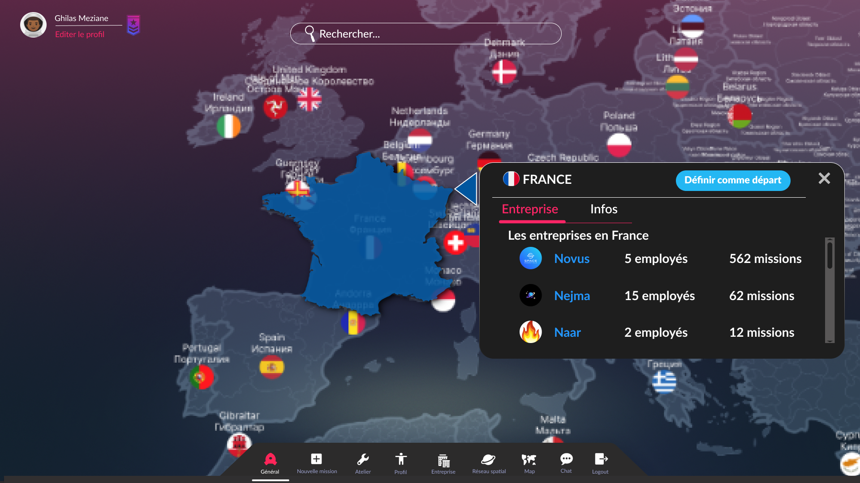

Figure 38: C000-1

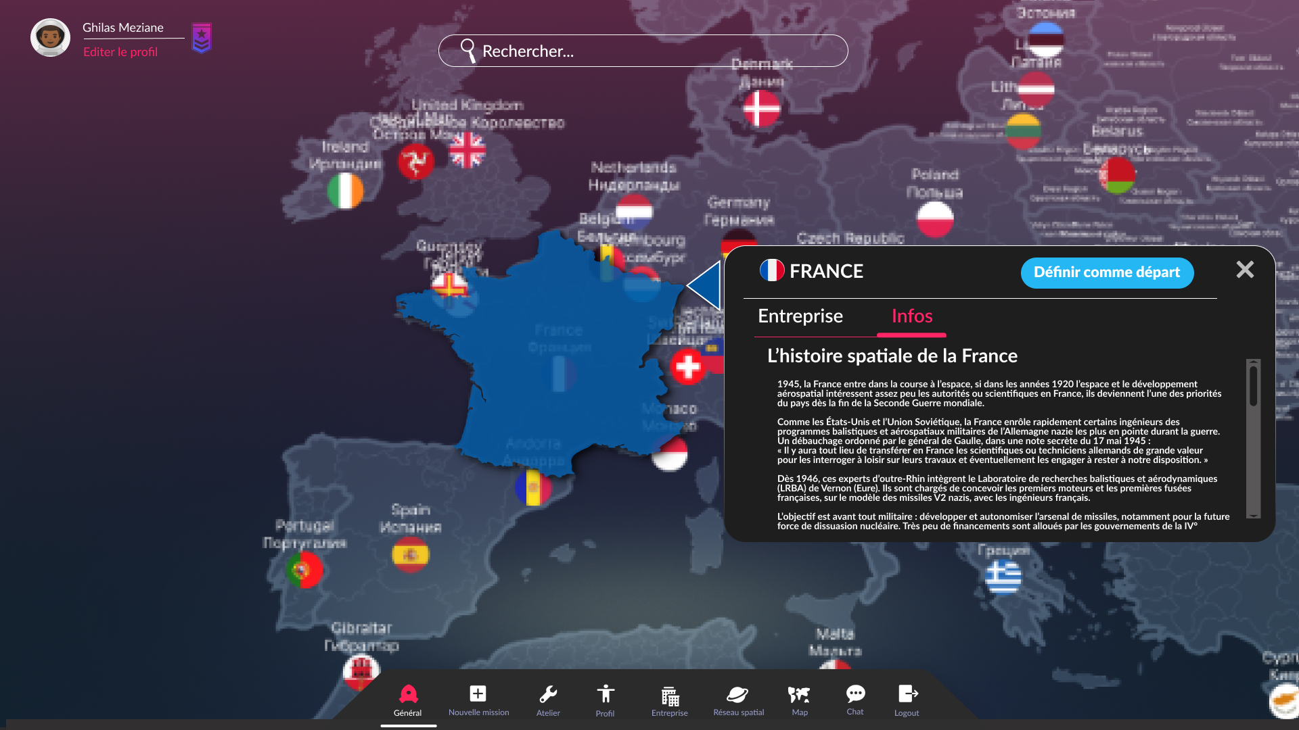

Figure 39: C000-2

# Construction de la fusée

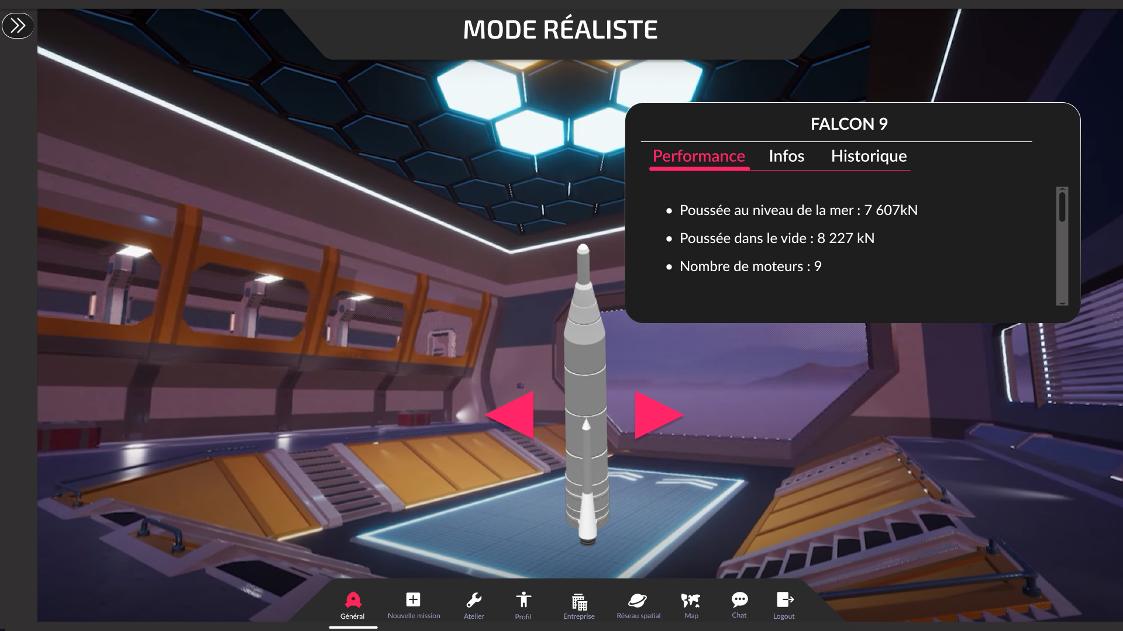

Figure 40: F000-0

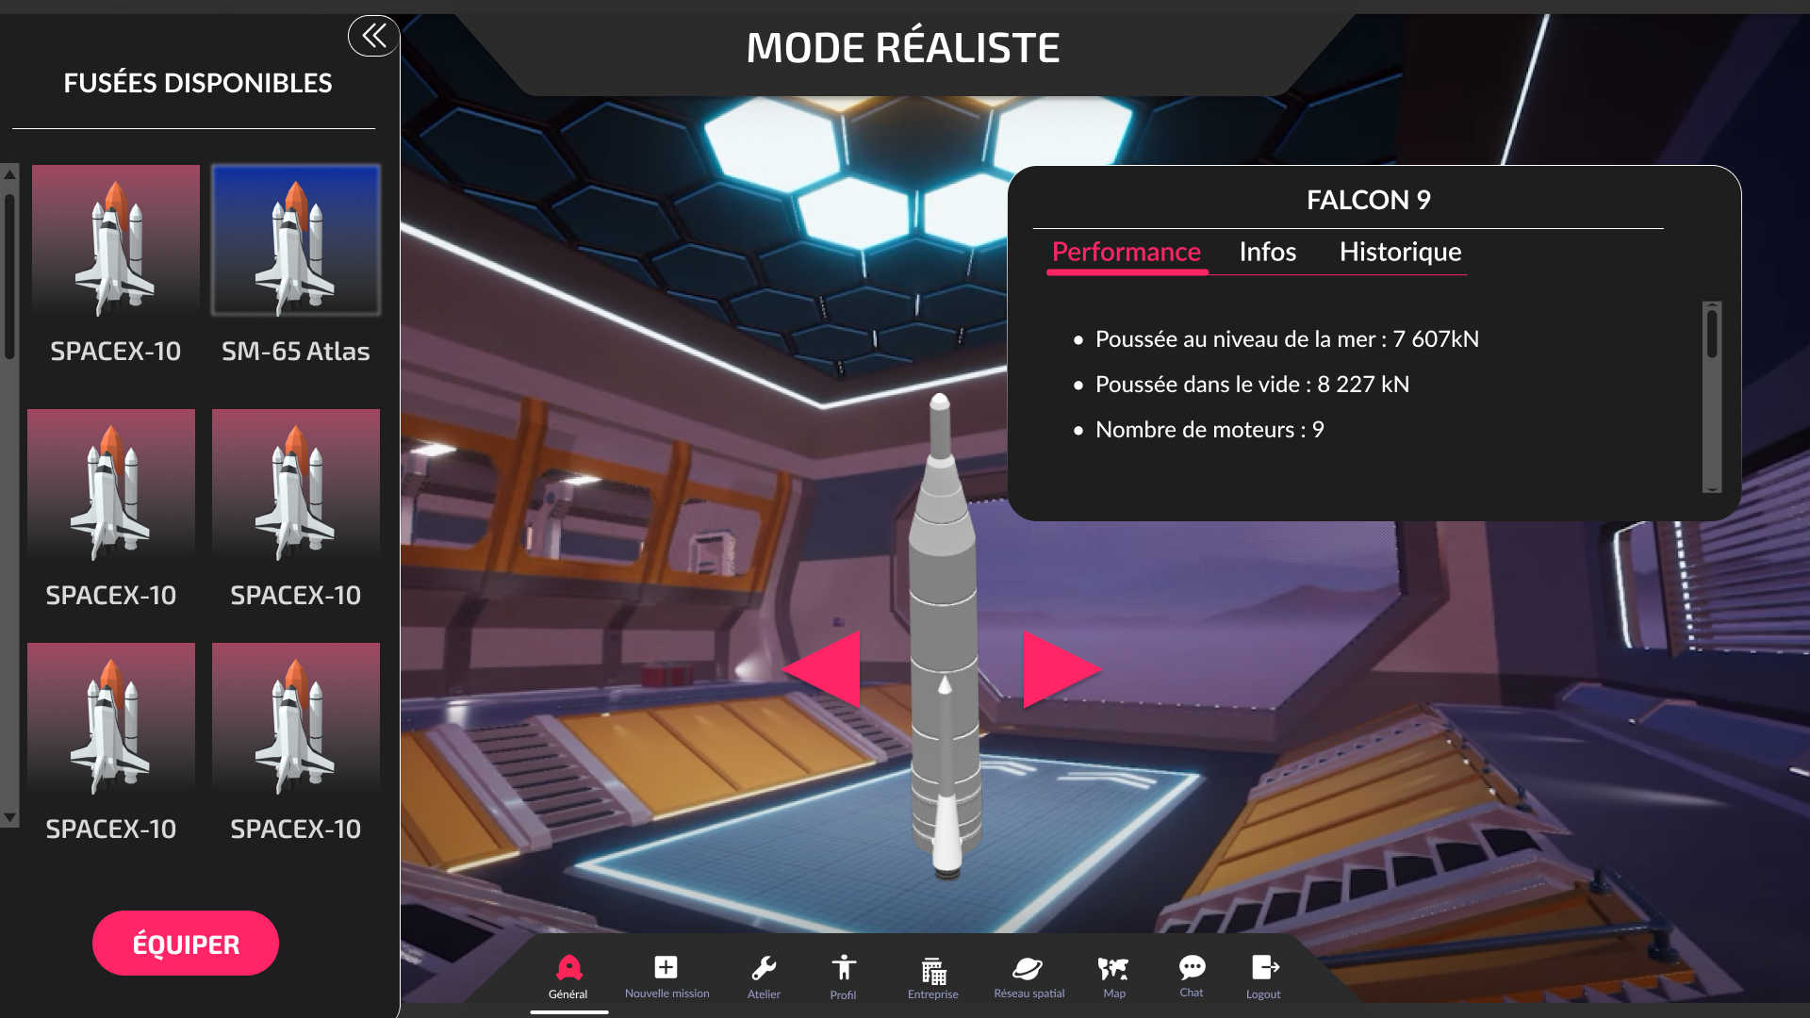

Figure 41: F000-1

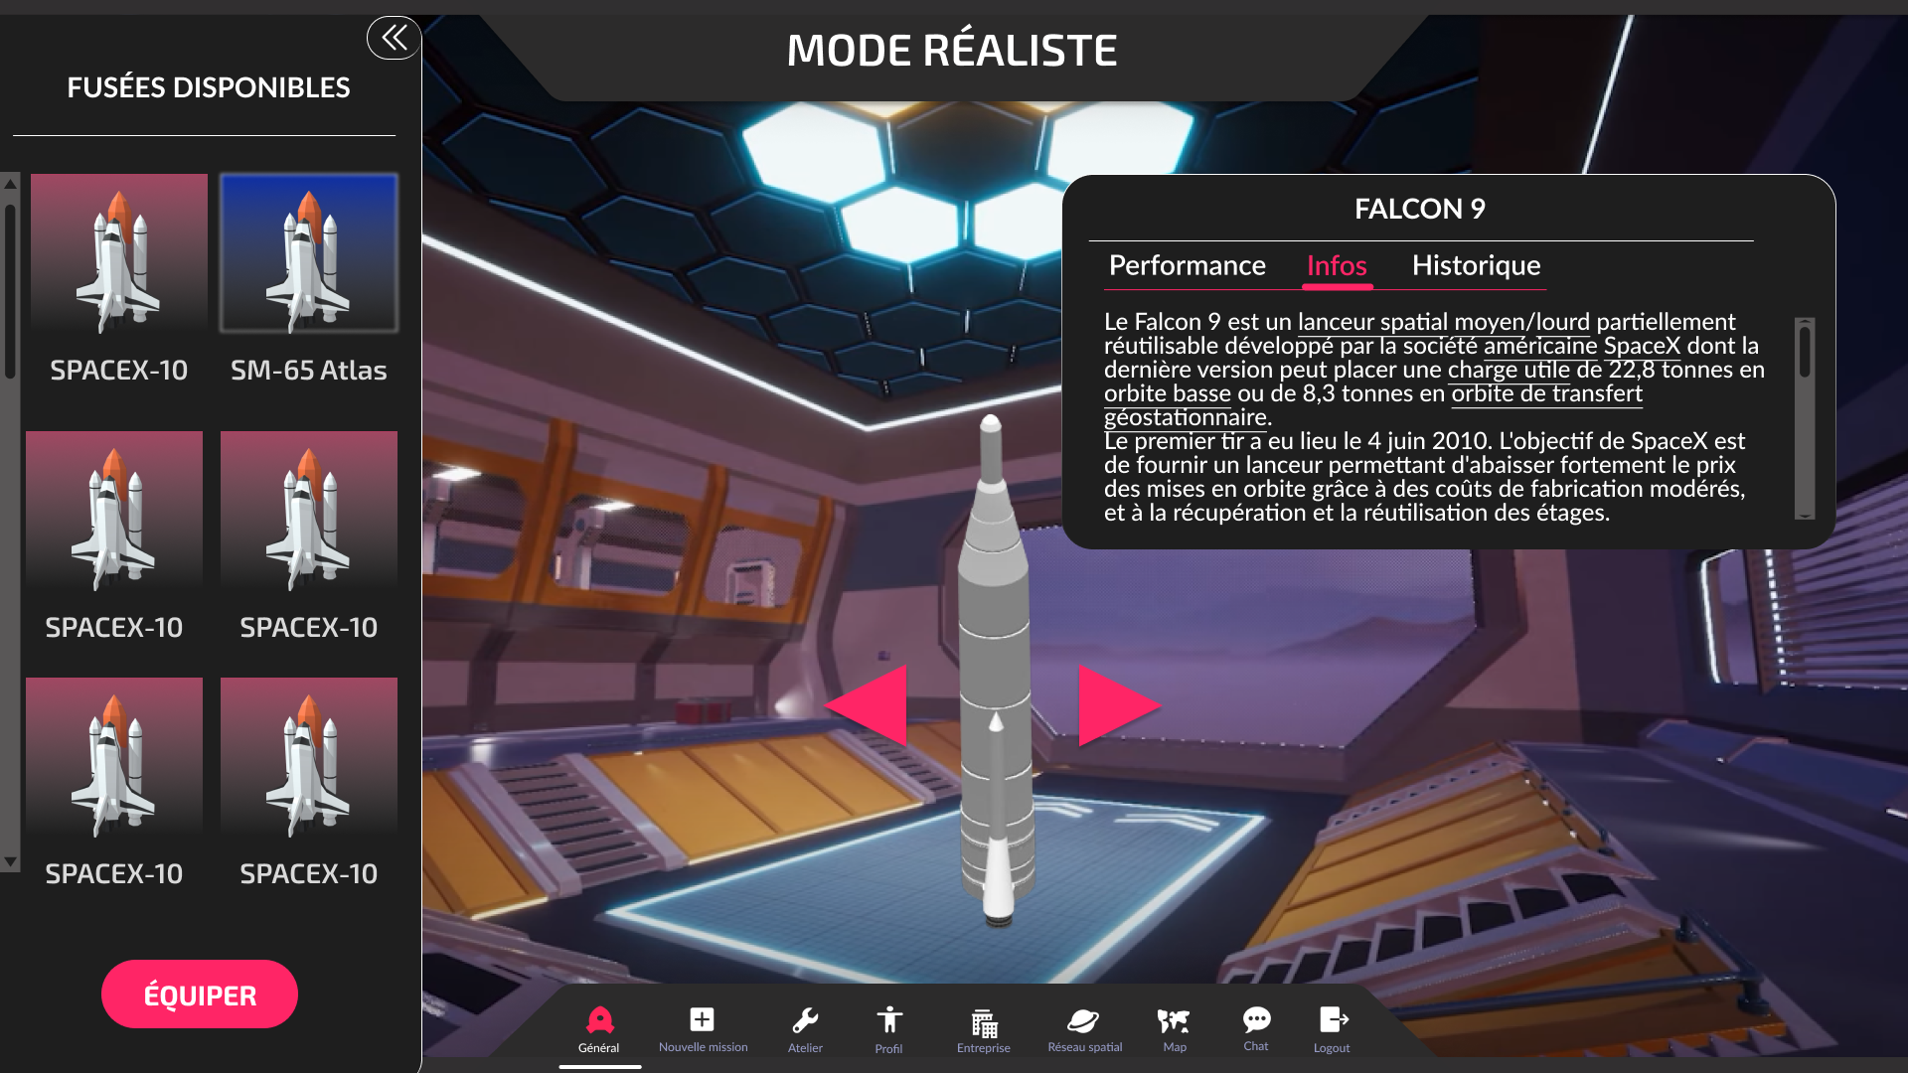

Figure 42: F000-2

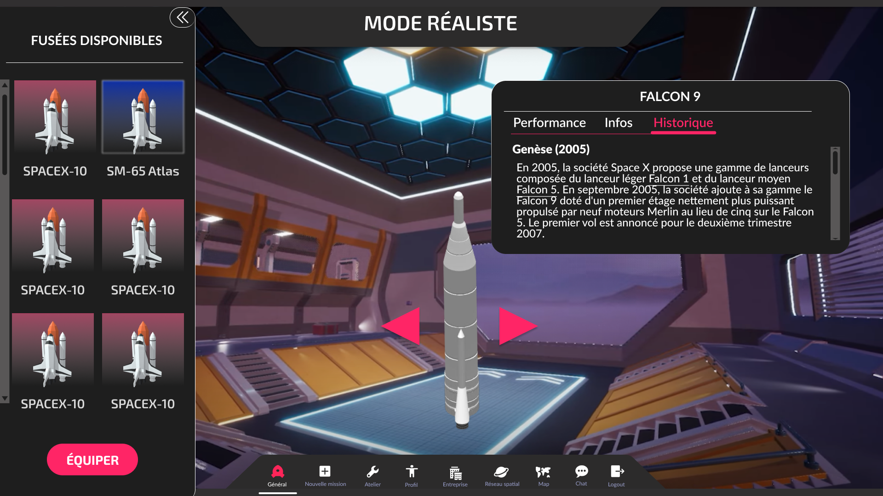

Figure 43: F000-3

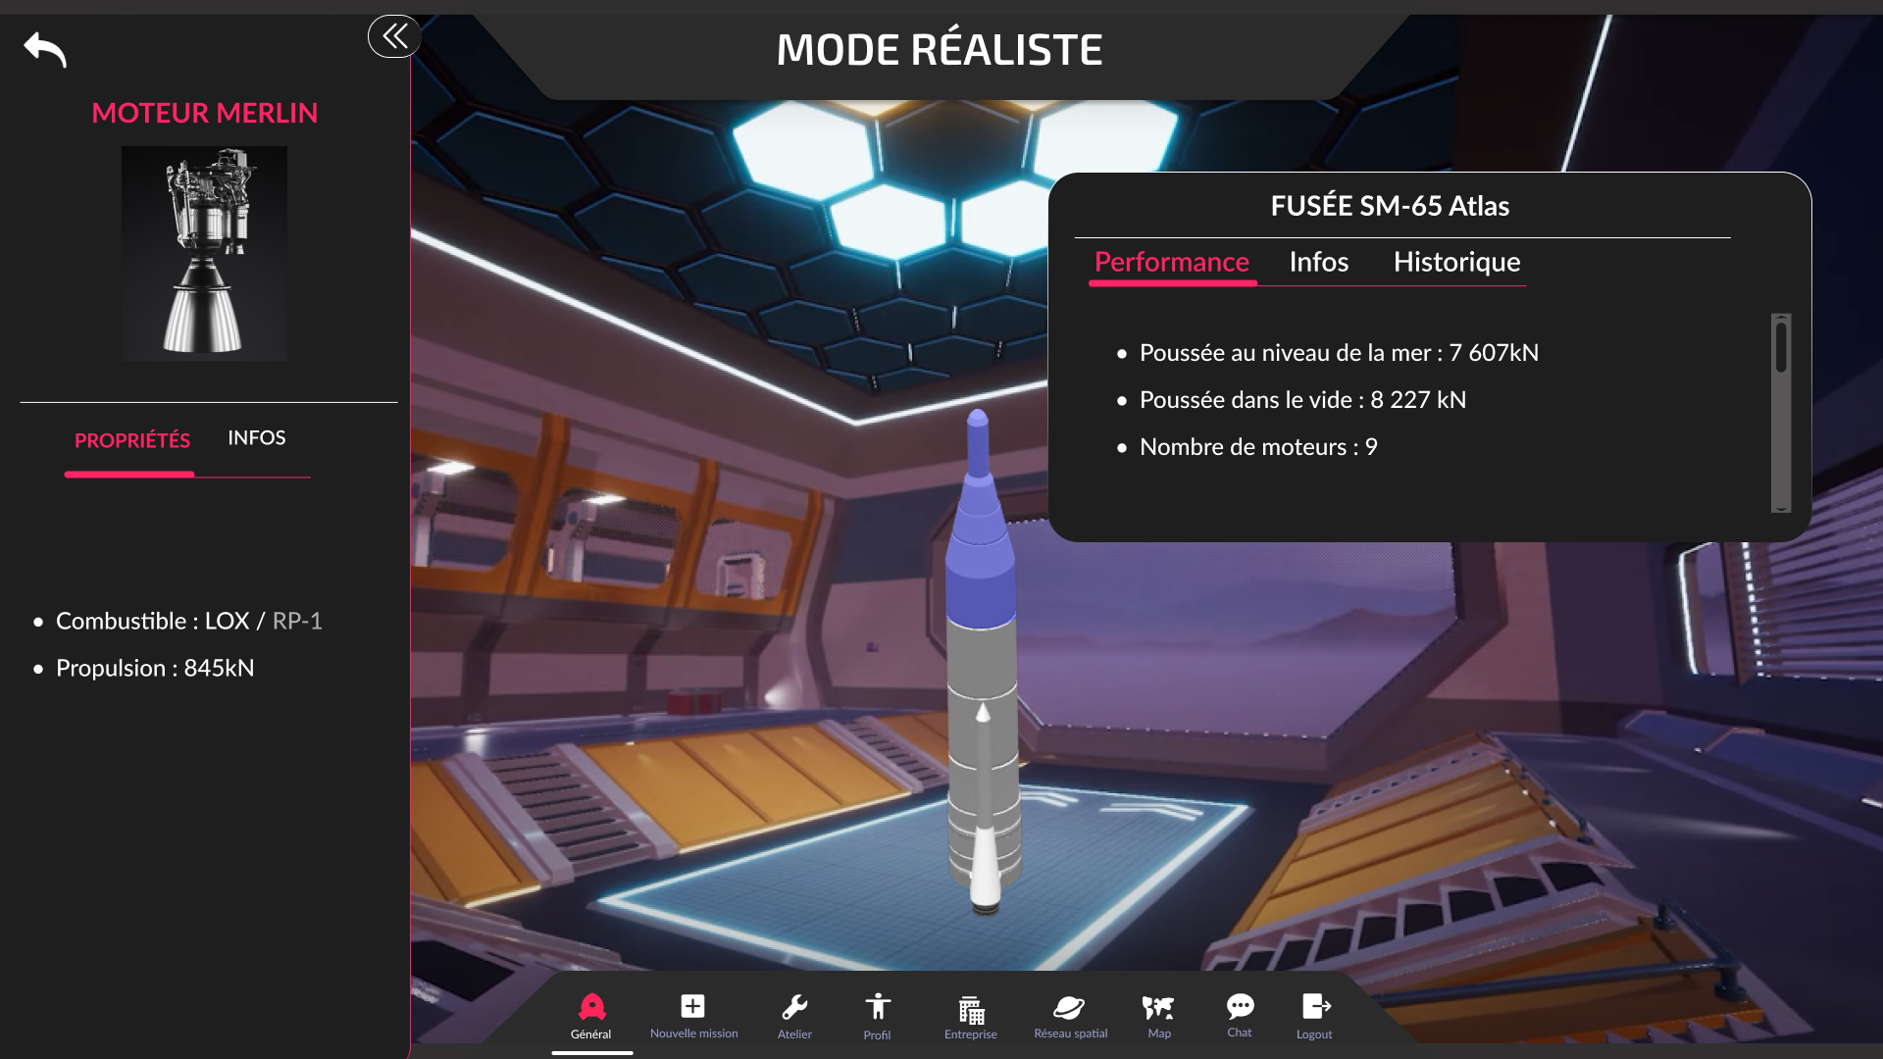

Figure 44: F001-0

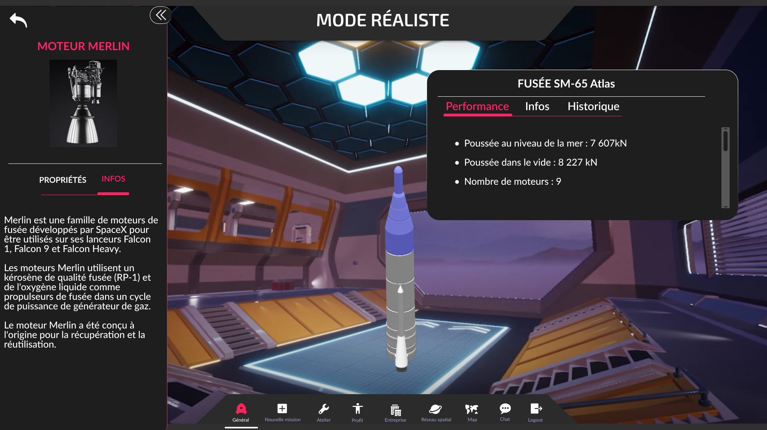

Figure 45: F001-1

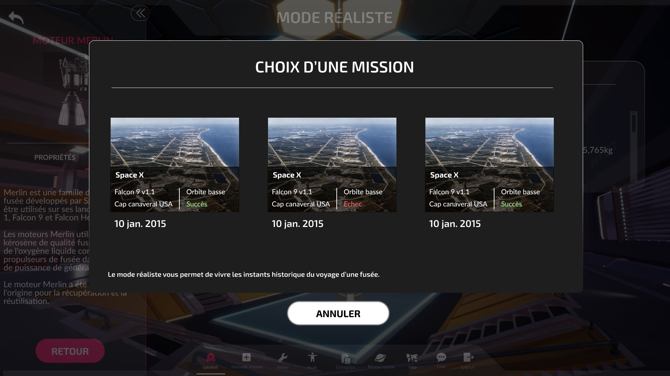

Figure 46: F002-0

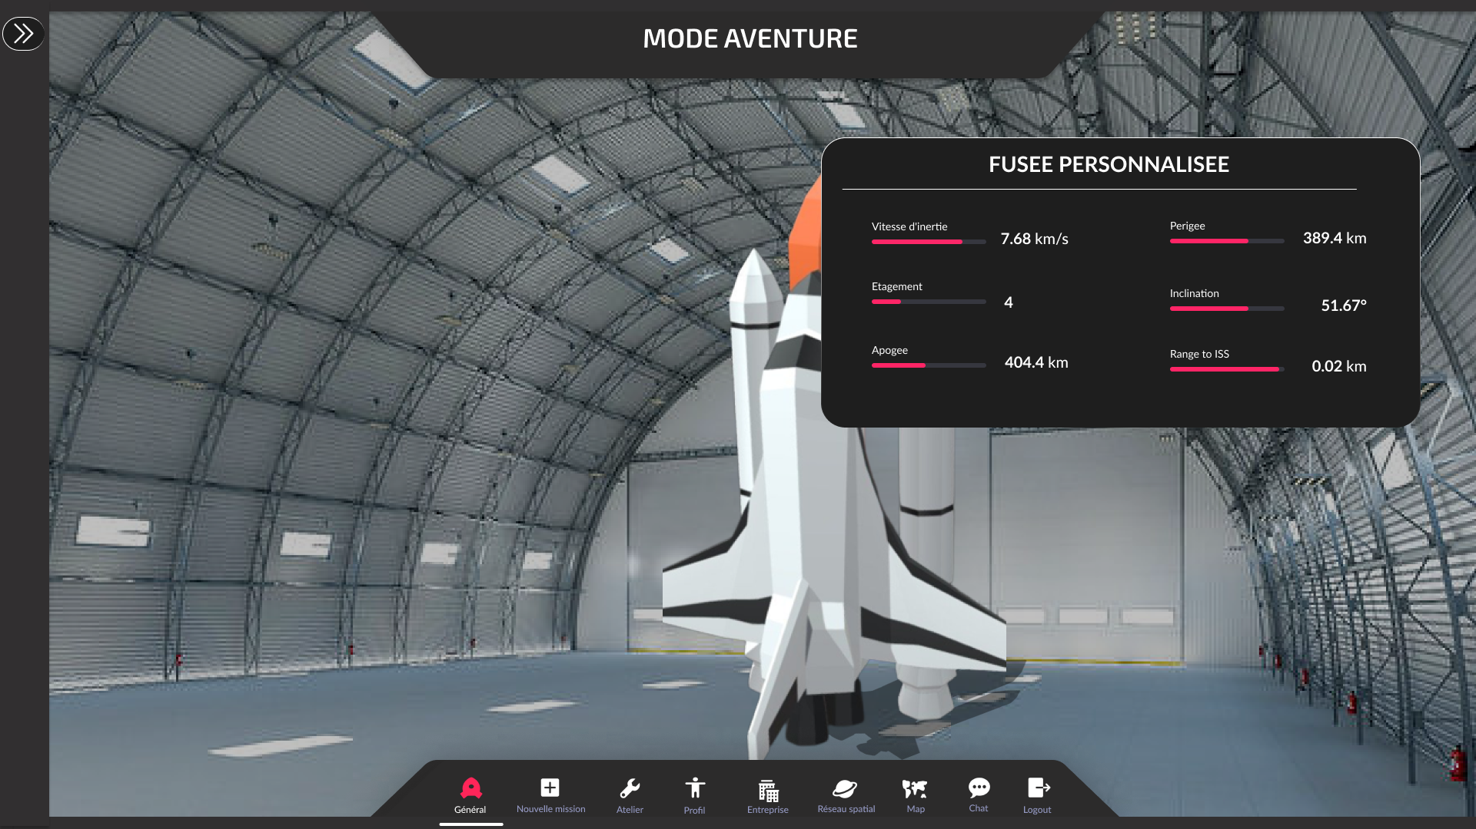

Figure 47: F003-0

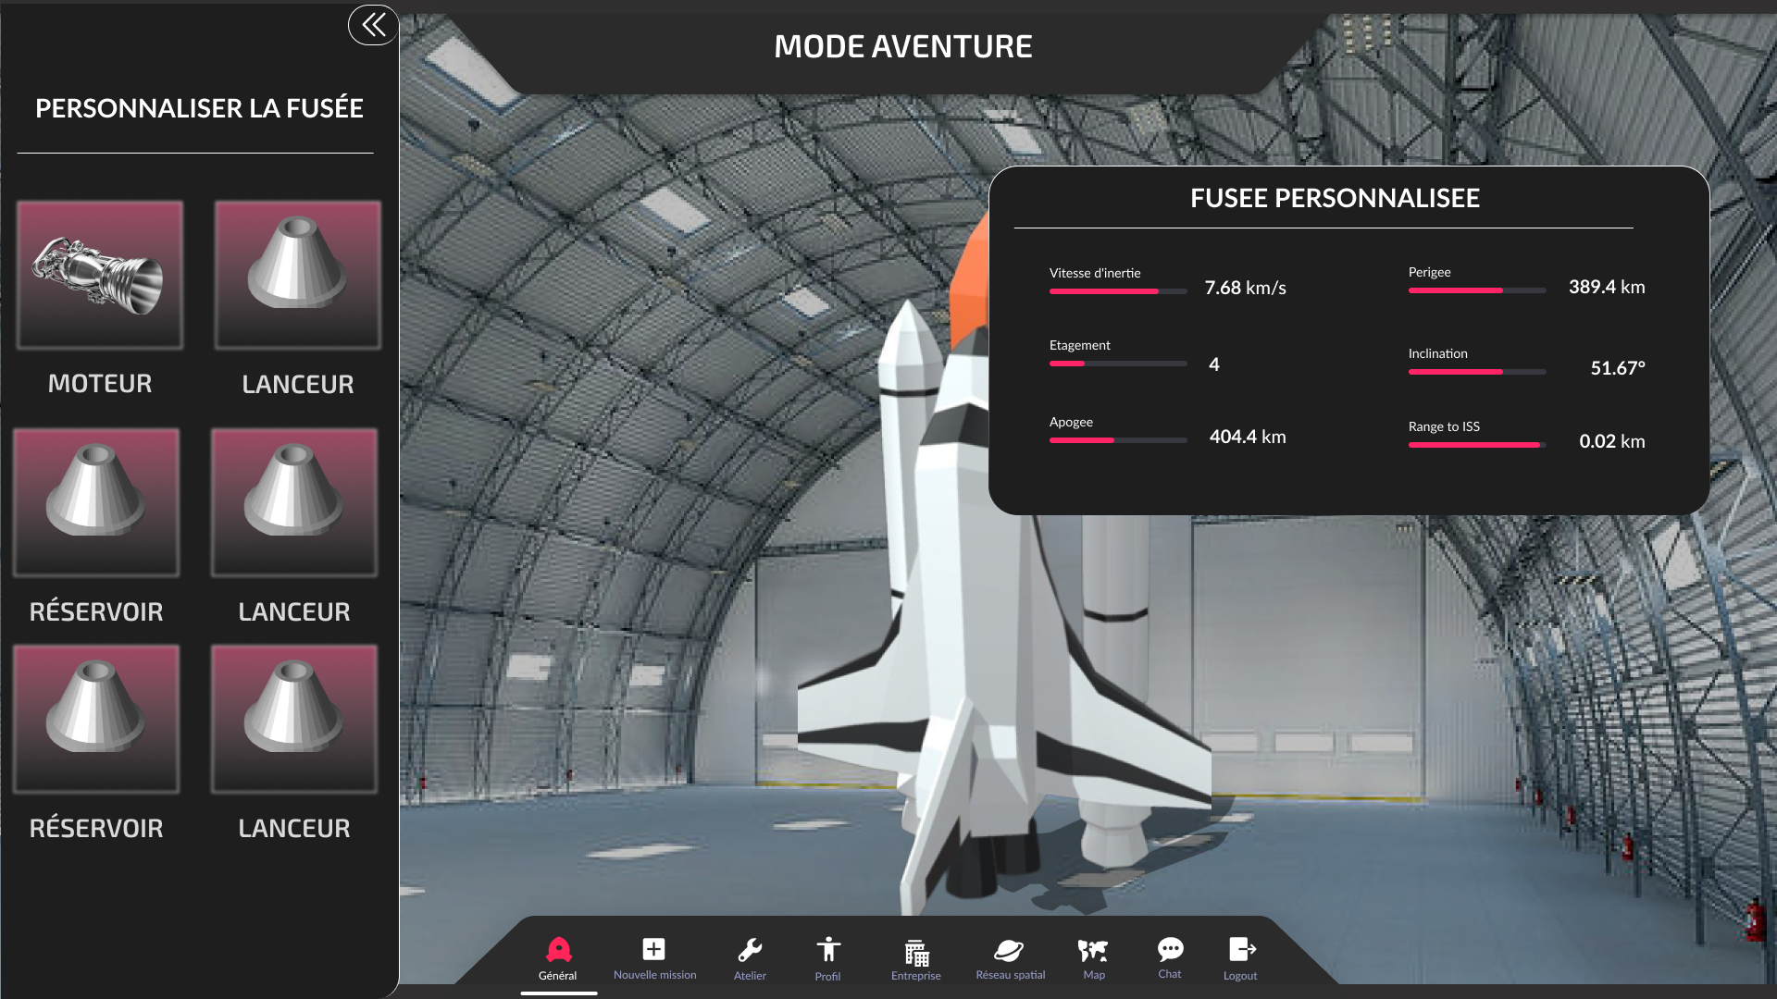

Figure 48: F003-1

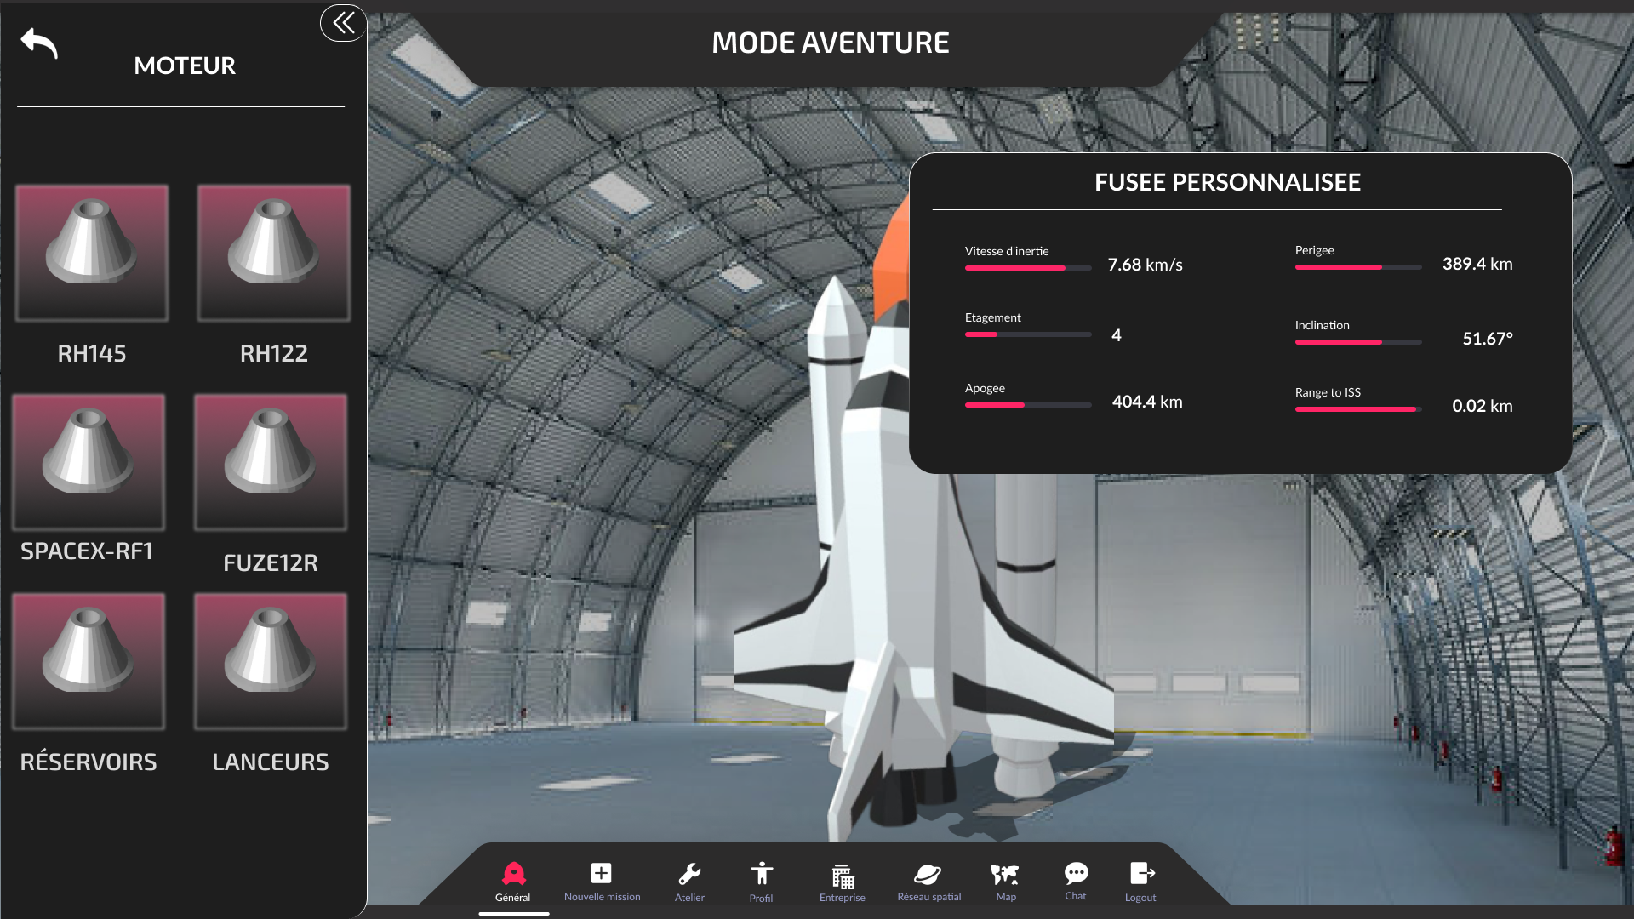

Figure 49: : F004-0

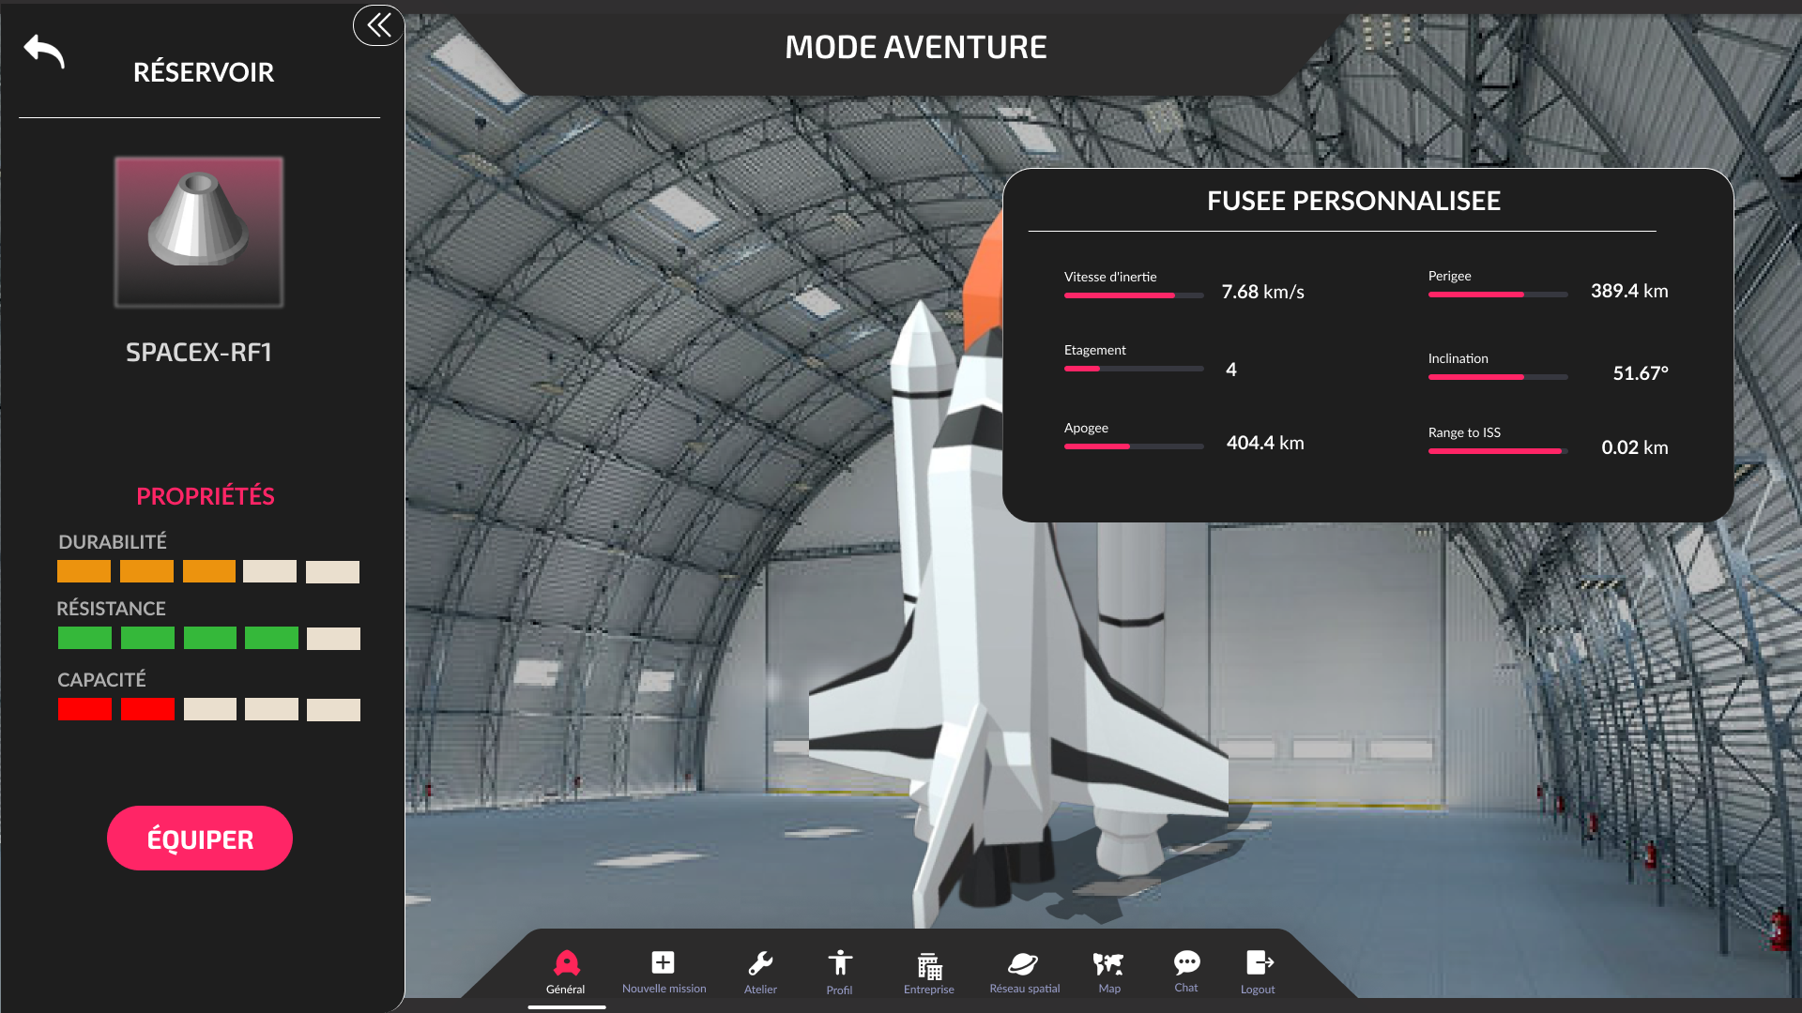

Figure 50: F005-0

# Réalisation de la mission

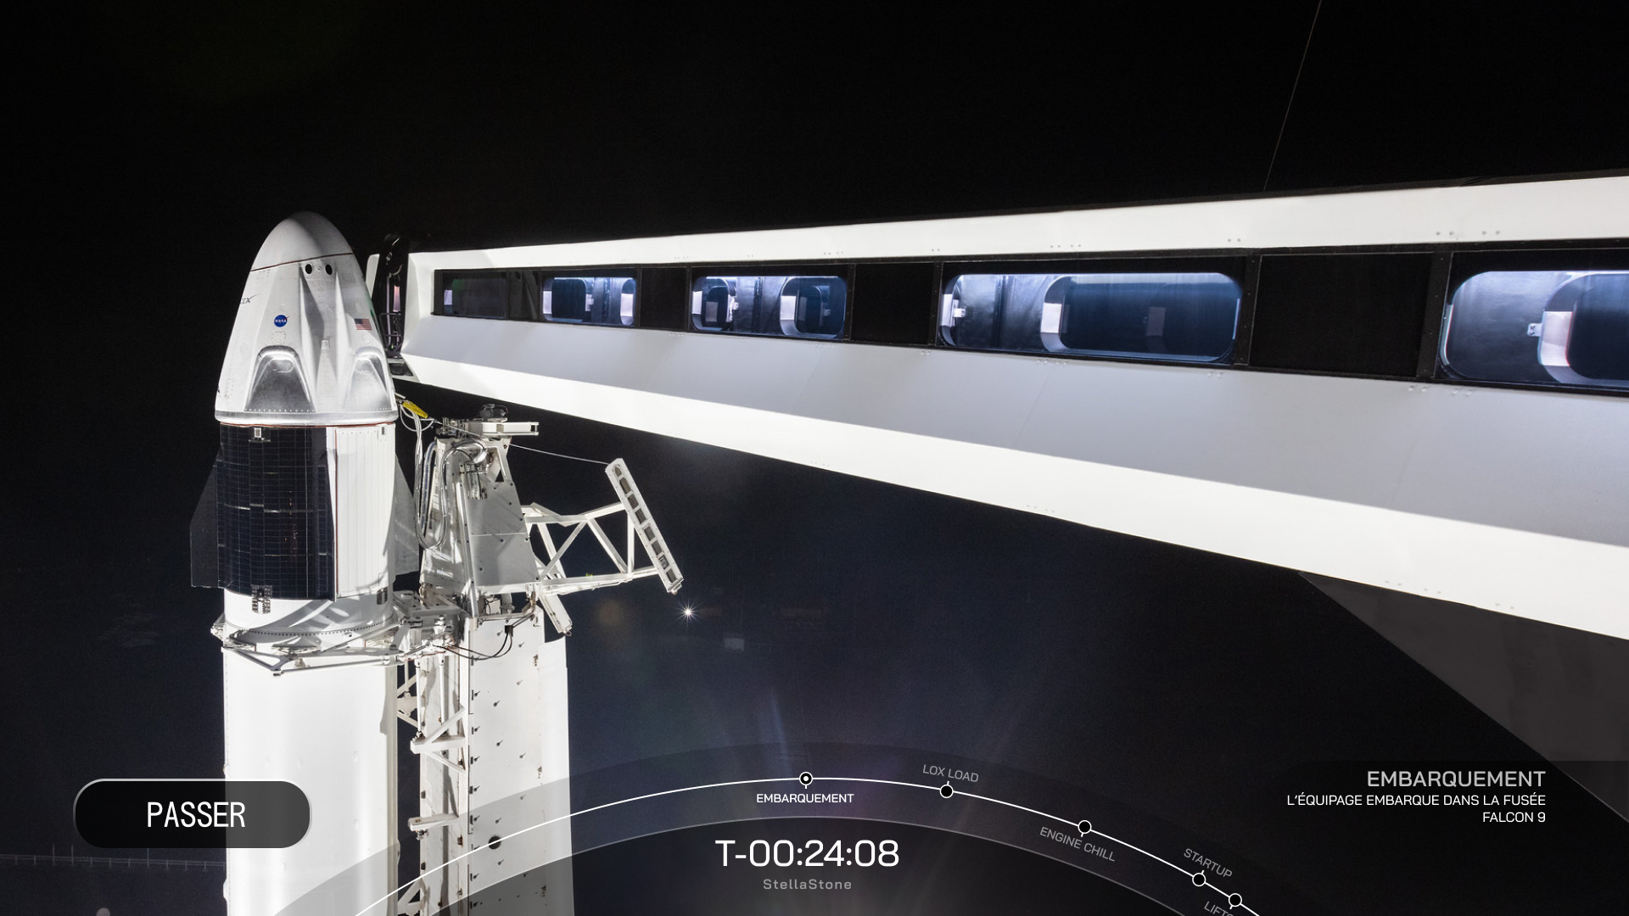

Figure 51: V001-0

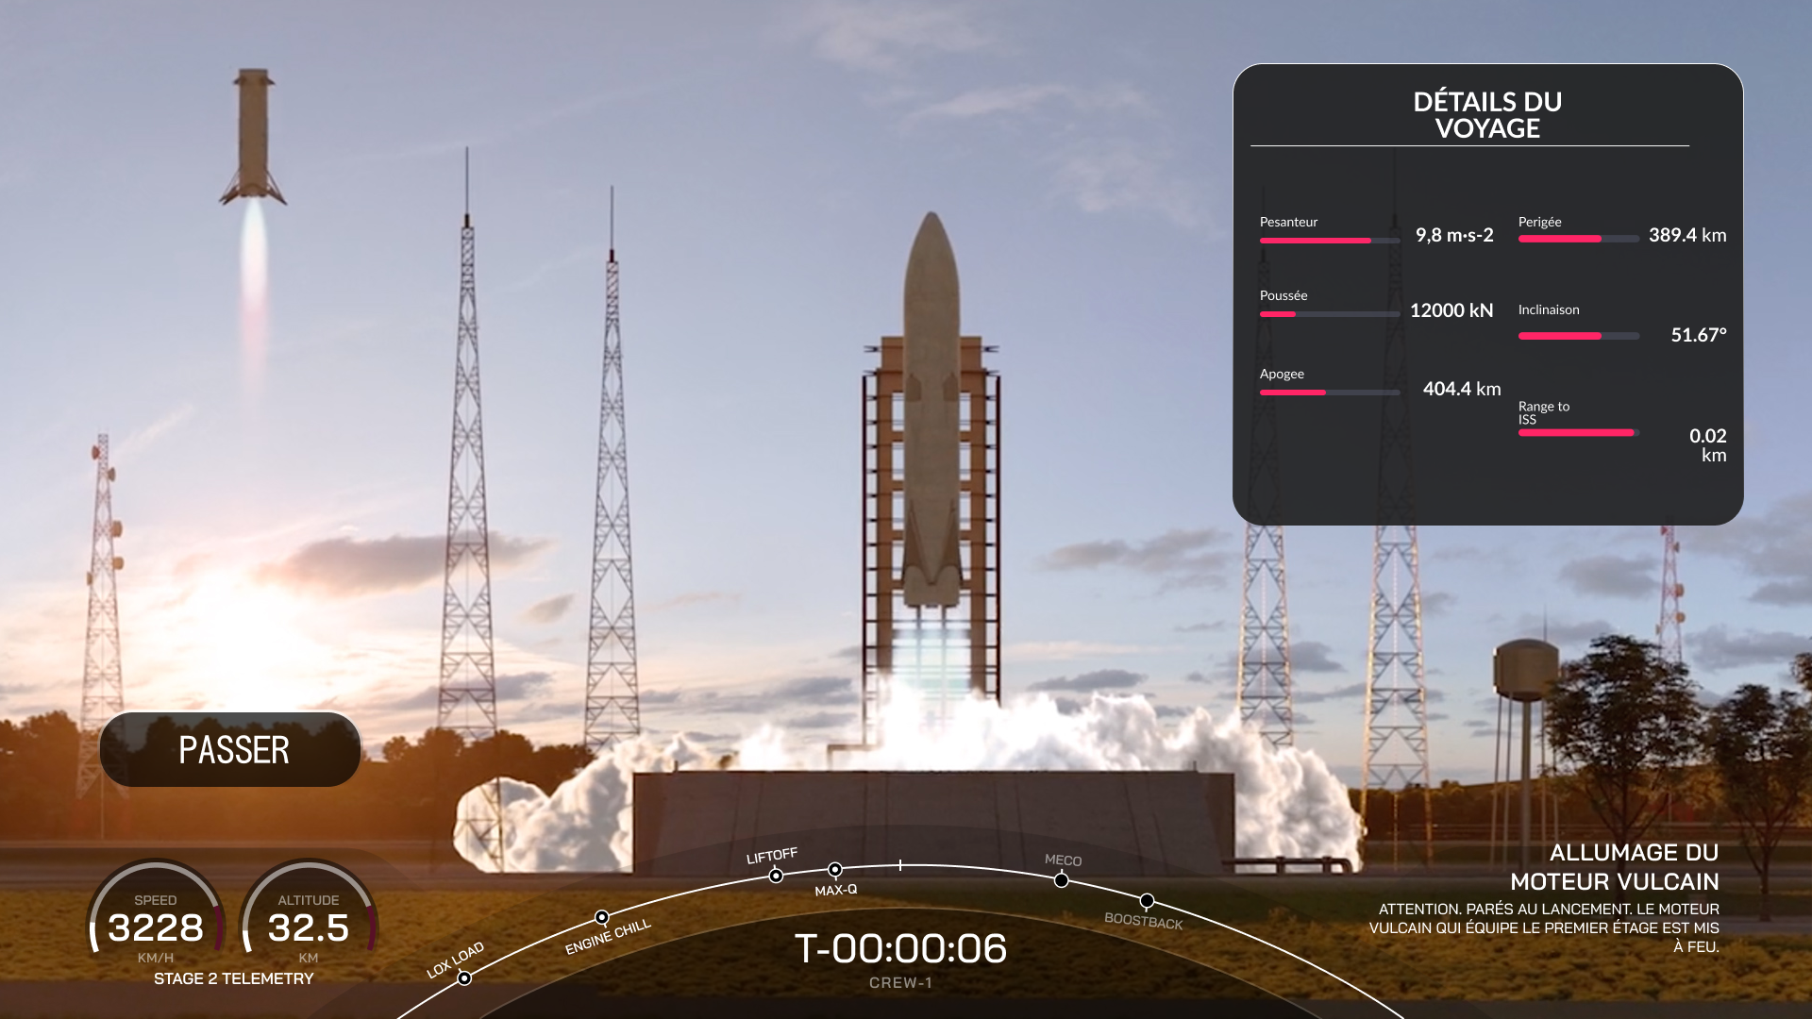

Figure 52: V001-1

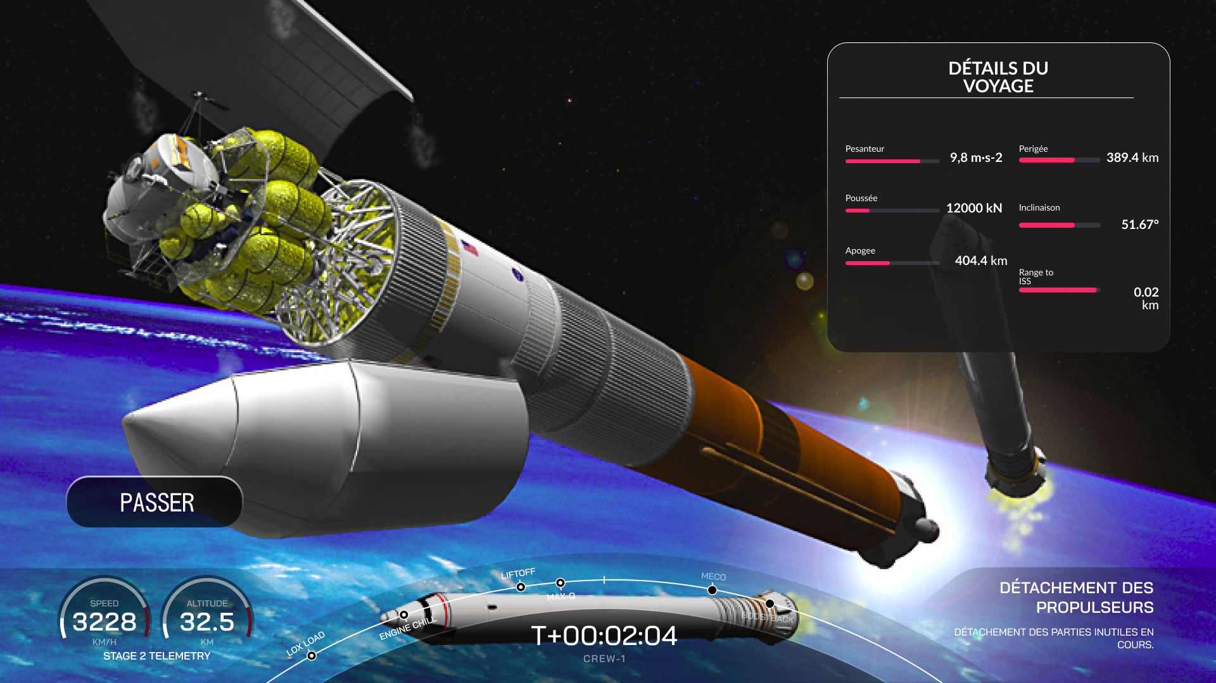

Figure 53: V001-2

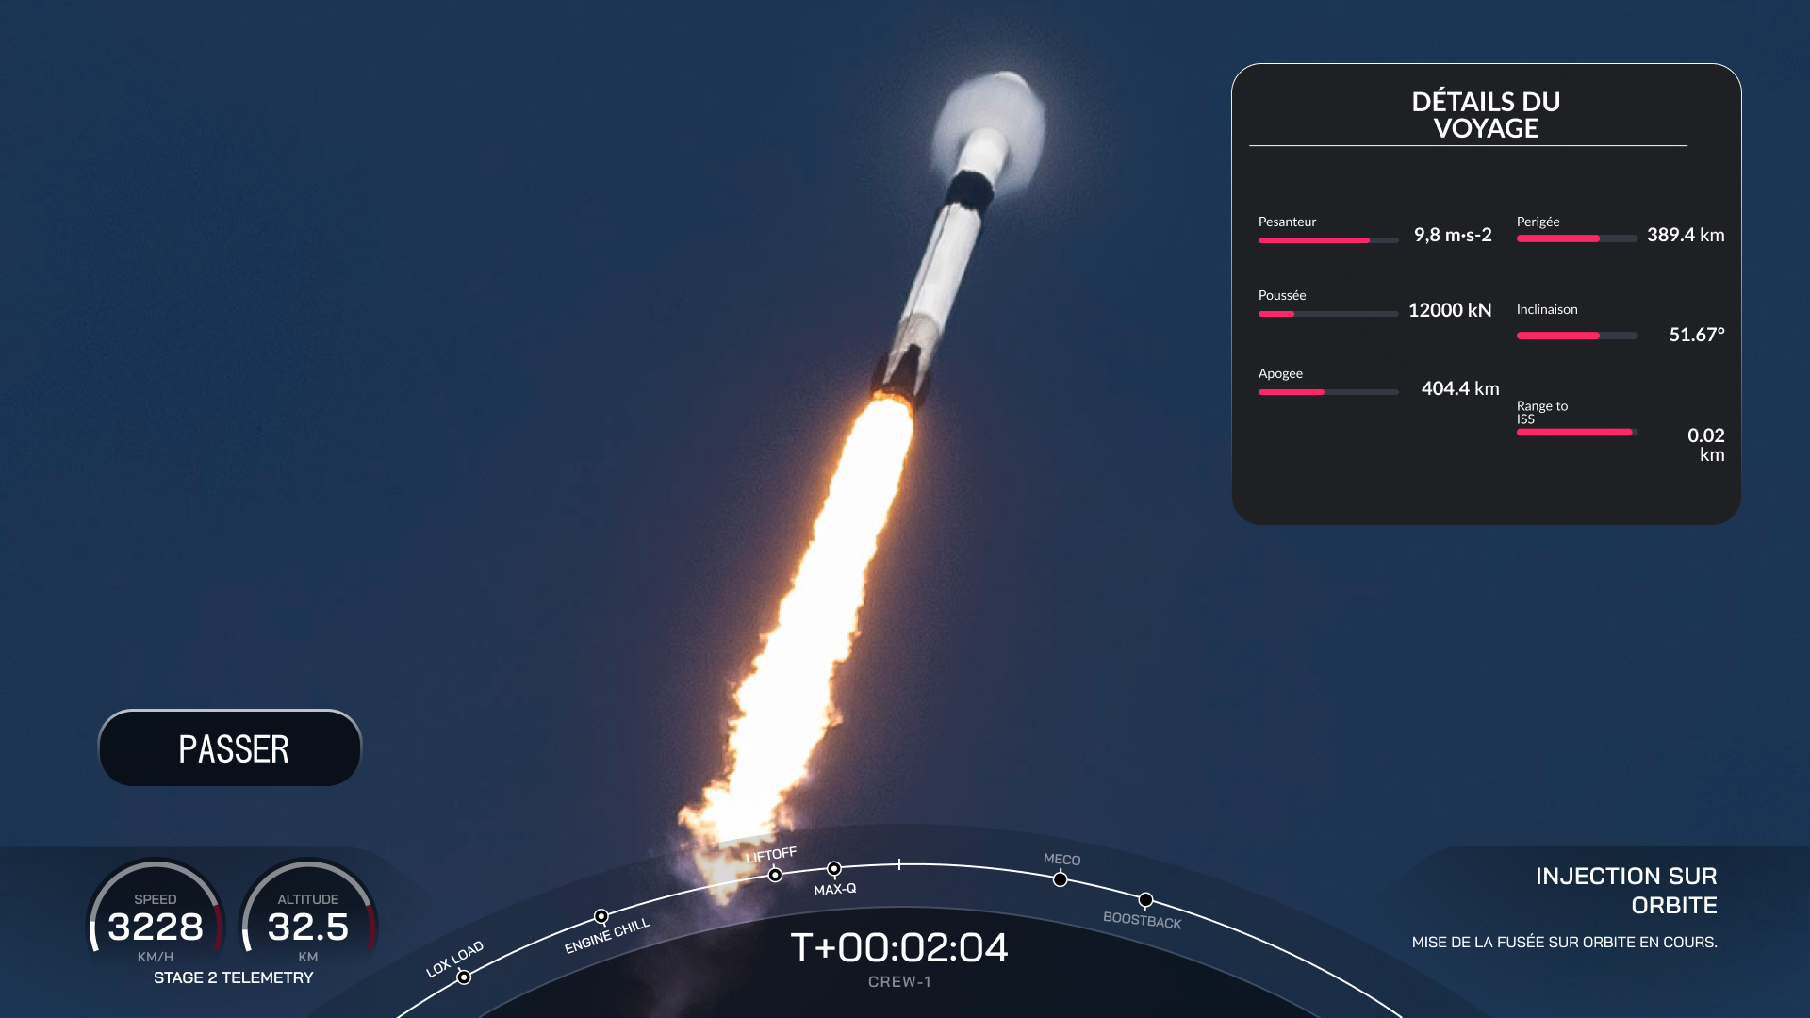

Figure 54: V001-3

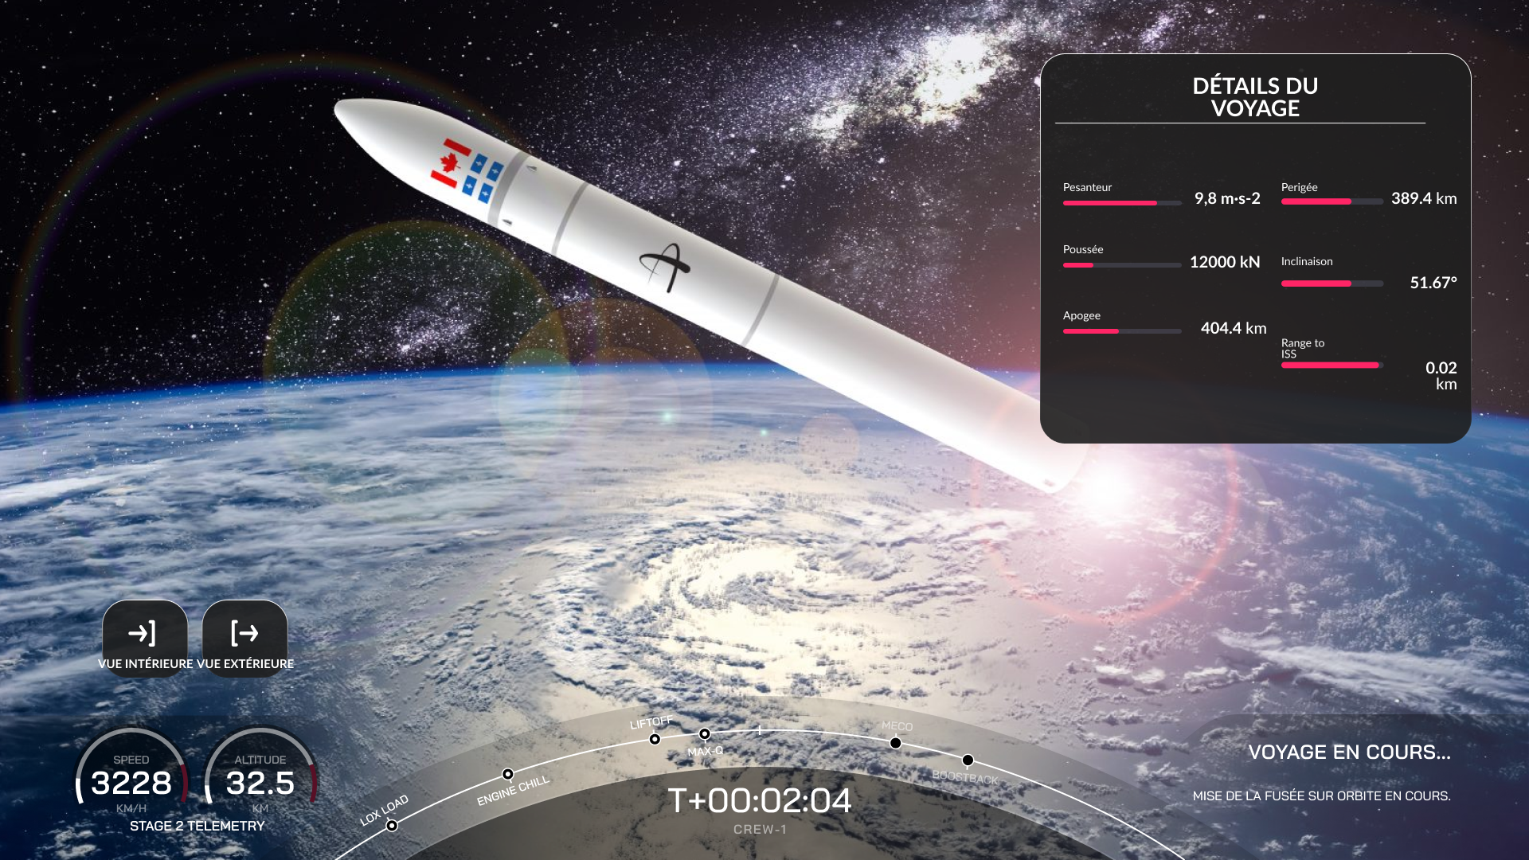

Figure 55: V001-4

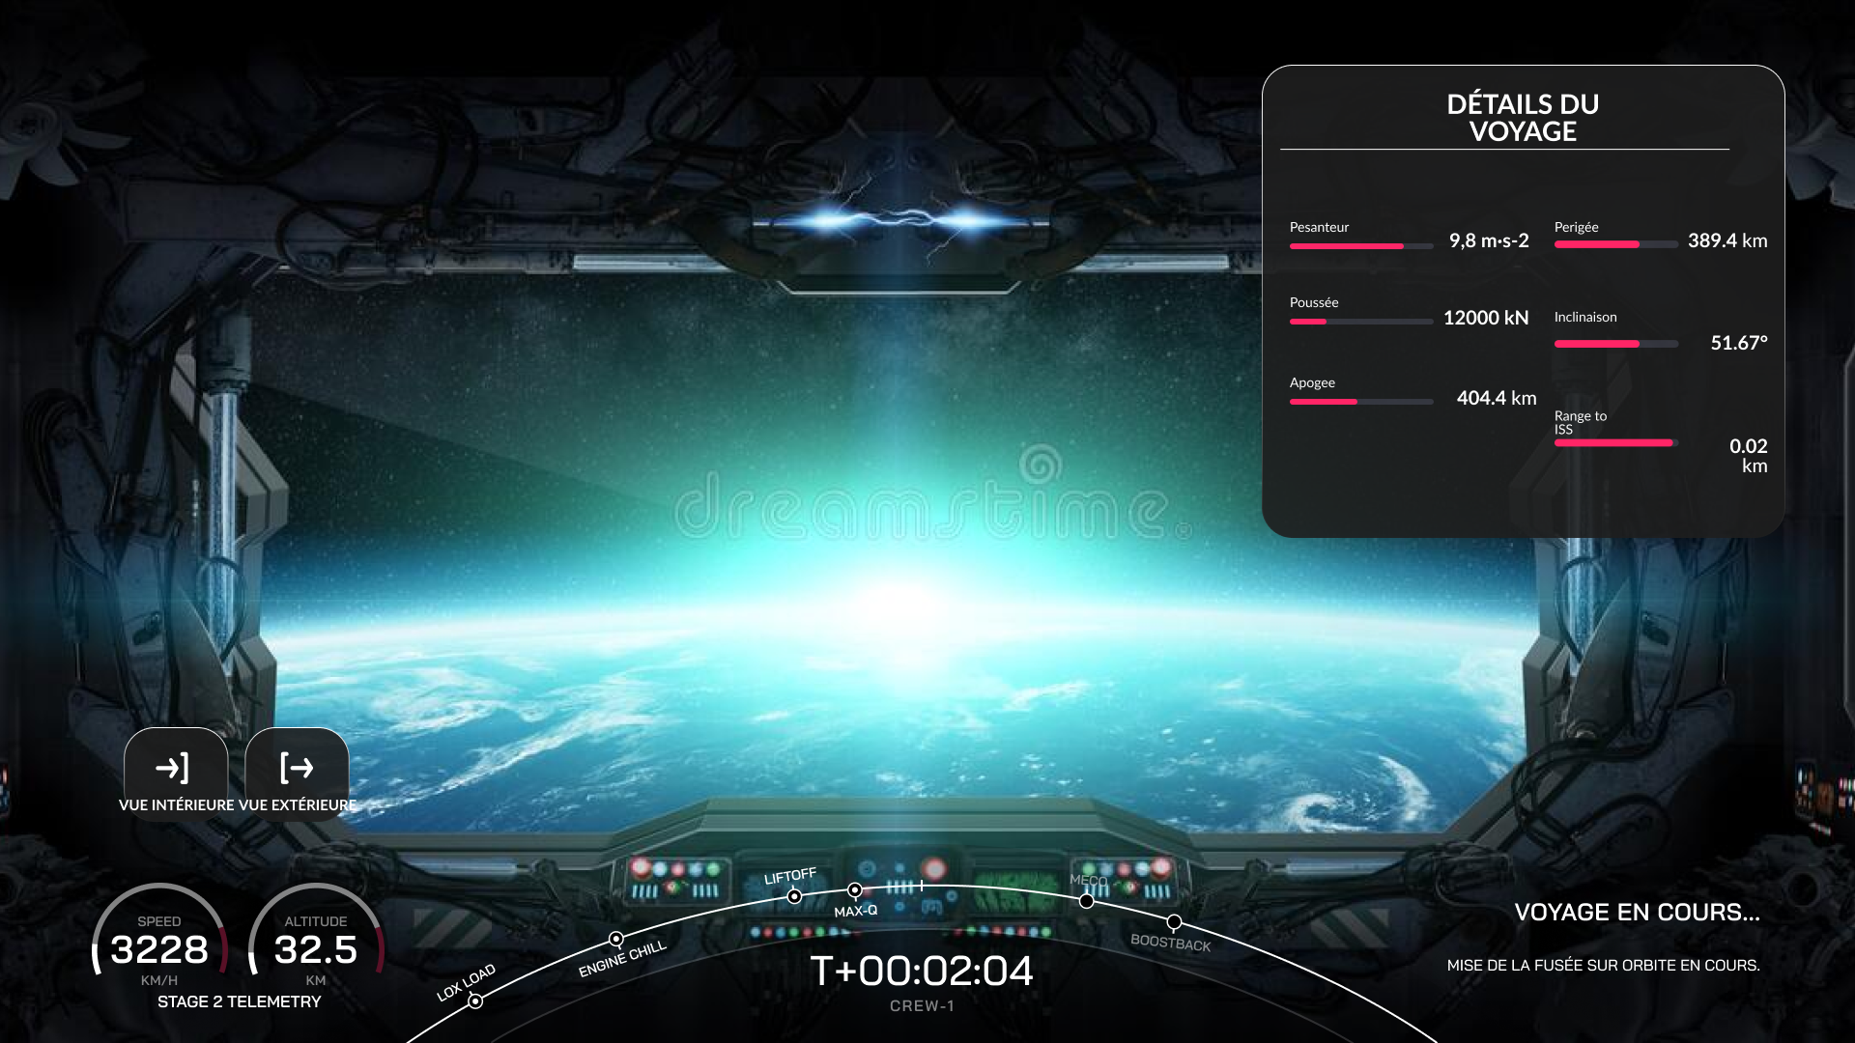

Figure 56: V001-5

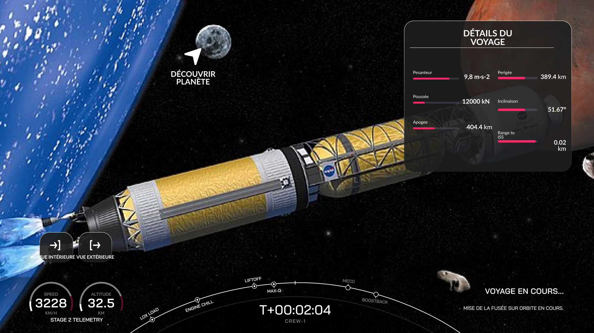

Figure 57: V001-6

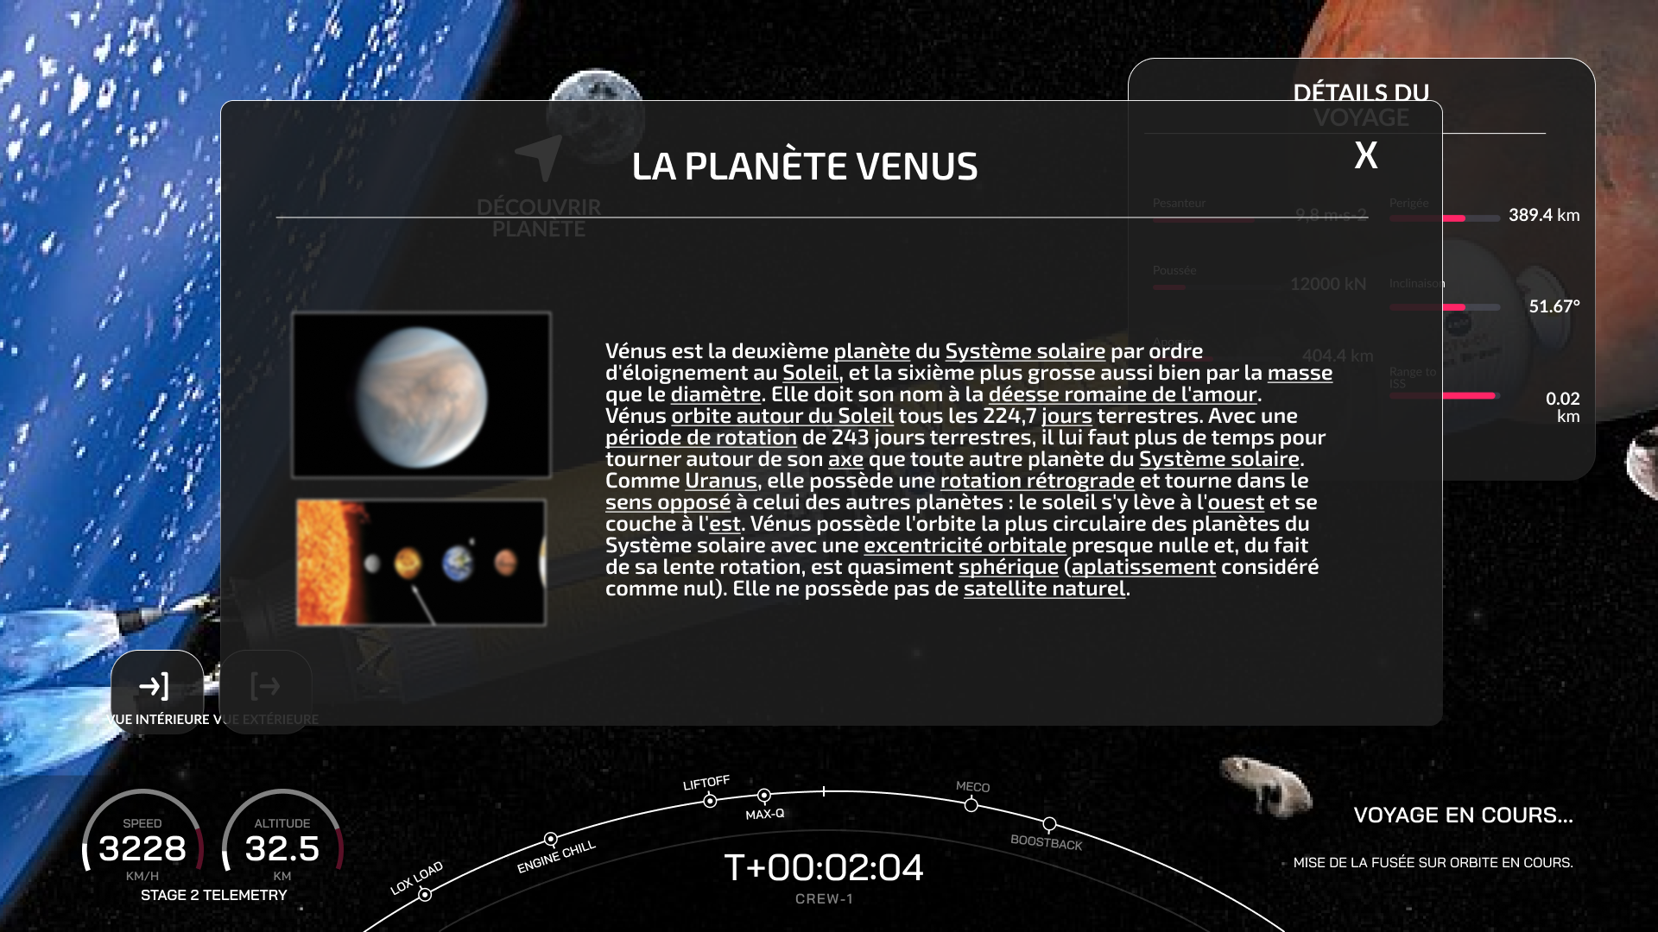

Figure 58: V001-7

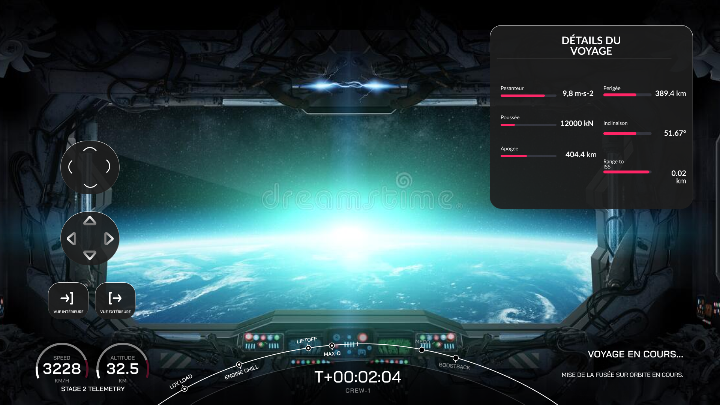

Figure 59: V001-8